Ticket Booking Management System
1 | P a g e

by

Md Riyajul Jannat

Id: CSE 01205995

This Project Report Presented in Partial Fulfillment of the Requirements for the Degree of Bachelor of Science in Computer Science & Engineering



Department of Computer Science & Engineering Port City International University
Chattogram, Bangladesh

March, 2021
Ticket Booking Management System

This Project Report Presented in Partial Fulfillment of the Requirements for the Degree of Bachelor of Science in Computer Science & Engineering

Supervised by
Mohammed Armanuzzaman Chowdhury
Lecturer, Department of CSE Port City International University

Department of Computer Science & Engineering Port City International University
Chattogram, Bangladesh

March, 2021
2 | P a g e
Approval for Submission

This project “Ticket Booking Management System” by Md Riyajul Jannat, Student ID: CSE 01205995, Batch: CSE 012 has been approved for submission to the Department of Computer Science & Engineering, Port City International University in partial fulfillment of the requirements for the degree of Bachelor of Science (Engineering).

…………………………………….

Signature of the Supervisor
Mohammed Armanuzzaman Chowdhury Lecturer,
Department of Computer Science & Engineering, Port City International University
S Khulshi Rd, Chattogram 4202
Chattogram, Bangladesh.
Email: Arman.cu.cse@gmail.com Telephone: 01925-568358
DECLARATION

I hereby declare that the whole project work has been done by me and not any portion of the work contained in support of any other application for any other qualification or degree of this or any other university or institution.

…………………………………..

Signature of the candidate
Md Riyajul Jannat ID: CSE 01205995

DEDICATION

This project is dedicated to

My beloved parents &
Honorable teachers

ACKNOWLEDGEMENT

At first, I would like to praise and thanks to almighty Allah, the most merciful and most beneficent for giving patience, courage, and great opportunity to develop the project within the meantime.

I am grateful to my project supervisor Mohammed Armanuzzaman Chowdhury for providing me his valuable time, motivation, guidance & support to complete this project perfectly.

I’m also grateful to our faculty members for their support and inspiration all through long.

ABSTRACT

Ticket is certification or token which we need when we travel from one place to another place through any vehicle, Launch, Airplane or for any event. This system allows us to book ticket online for bus, launch, air, events, movie. We can check upcoming events also with this system. It provides all the facility to user to book and manage ticket online easily. User can book their ticket anytime online with this system. User can compare ticket price because a lot of agencies are available here. User can search for events with location. User can search for movies with location and date they don’t have to input movie name. They can see all movie list of that location on that date. In summary, this system will fulfil all user requirements to book ticket online compare to other system.
Table of Contents

List of Tables viii
List of Figures ix

Chapter 1 | Problem Definition | 1 - 4
 | 1. Problem Statement | 1
 | 2. Project Objectives | 1
 | 3. Preliminary Solution | 2
 | 4. Project Scope | 2
 | 5. Estimated Cost and Time for Feasibility Study | 3
 | 6. Organizations of the Report | 3
Chapter 2 | Feasibility Study | 5-10
 | 1. Background | 5
 | 2. System Outline | 5
 | 3. Methodology | 6
 | 4. Overview of Alternatives | 7
 | 5. Recommendation | 9
 | 6. Conclusion | 10
Chapter 3 | Project Planning | 11-17
 | 1. Project Organization | 11
 | 2. Risk Analysis | 11
 | 3. Hardware and Software Resource Requirement | 15
 | 4. Work Breakdown | 15
 | 5. Project Schedule | 16
 | 6. Monitoring and Reporting Mechanism | 17
 | 7. Conclusion | 17
Chapter 4 | Software Requirements Specification | 18-24
 | 1. Preface | 18
 | 2. Introduction | 18
 | 3. Glossary | 19
 | 4. User Requirements Definition | 19
 | 5. System Architecture | 20
 | 6. User Requirements Specification | 20
 | 7. System Evolution | 21
 | 8. Appendices | 21
 | 9. Index | 23

Chapter 5 | System Designing | 25-28
 | 1. Architectural Pattern | 25
 | 2. System Diagram | 26
 | 3. ER Diagram | 27
 | 4. Conclusion | 28
Chapter 6 | Implementation | 29-36
 | 1. System Demonstration | 29
Chapter 7 | Conclusion | 37-37
 | 1. System Limitation | 37
 | 2. Future work | 37
 | 3. Conclusion | 37
 | Appendices | 38-49

List of Tables
Table Name Description of Tables

Chapter 1 Problem Definition
Table 1.1 Project Scope
Chapter 2 Feasibility Study
Table 2.1 System Outline
Table 2.2 Overview of Alternatives
Table 2.3 Summary of cost for alternative 1 Table 2.4 Summary of cost for alternative 2 Table 2.5 Benefits and Cost for alternative 1 Table 2.6 Investment analysis for alternative 1 Table 2.7 Benefits and Cost for alternative 2 Table 2.8 Investment analysis for alternative 2 Table 2.9 Comparison between alternatives
Chapter 3 Project Planning
Table 3.3 Role of Team Member
Table 3.2 List of possible risks
Table 3.3 Possibility and Effect of the risks Table 3.4 Risk Reduction Strategies
Table 3.5 Hardware and Software Resource Requirement Table 3.6 Task Summary
Table 3.7 Milestone and Deliverables Table 3.8 Schedule Representation Table 3.9 Task Distribution
Chapter 4 Software Requirements Specification
Table 4.1 Glossary
Table 4.2 Definition of User Requirements Table 4.3 Specification of User Requirements Table 4.4 List of Use Cases
Table 4.5 Server Specification Table 4.6 Database Specification Table 4.7 List of Figures

List of Figures

Figure Name Description of Figure

Chapter 4 Software Requirements Specification
Figure 4.1 System Architecture
Figure 4.2 Use Case Diagram
Chapter 5 System Designing
Chapter 5.1 Architectural Pattern of Ticket Booking

Chapter 1 Problem Definition

The “Ticket Booking Management System” is an internet-based software which helps to book ticket online and passenger a can see available ticket and can choose bus ticket from the system.
It will be designed to manage a Ticket Booking all functions like choose bus seat by check available seat, book launch ticket, air ticket, events ticket, movie ticket by check available ticket, print booked ticket from system. Agency could be adding bus info, launch info, air info, event info, movie info and can manage added bus, launch, air, event, movie list, agency can see booked ticket list and can manage those ticket if they have to cancel it. The system will ensure manage the Ticket Booking very easily. At first, passenger can see the ticket information without log in to system if they need to book ticket they have to sign up to the system, passenger can see available seat before booking. Passenger can see bus seat availability before booking and can choose seat for book. Passenger have to bKash their ticket advance to confirm ticket. Agency can manage vehicle or ticket information and can see booked list individually. Agency can cancel ticket booking if they have to but they have to back ticket price directly to passenger within 72 hours.
The project is summarized through six sections which are briefly described as following: Section 1: describes the problems with the current Ticket Booking management system. Section 2: The purpose of this project is described briefly.
Section 3: Provides and discusses preliminary solutions to this problem. Section 4: Scope and limitations of the project are described.
Section 5: Present the estimate cost and required time for the feasibility studies. Section 6: Present the organizations of the report.

Problem Statement
Many agencies have its own ticket booking software but they can’t meet the expectation of passengers. The present system has the following problems:
    - Passengers have no option if they don’t get seat.
    - Passengers can’t check other companies ticket price or facility.
    - Passengers can’t book all type of system in one system.
    - Passengers have to give full price of ticket as advance & sometimes they cheated by agencies.
    - Passengers not friendly with agencies software environment because there is no instruction for passengers how to use it.

Project Objectives
The project objectives are described below:
    - To help passengers to check all agencies ticket and compare price.
    - To ensure availability of seat and choose bus seat from system.
    - To book all type of tickets like bus, launch, air, event, movie in one place.
    - To ensure ticket advance system easily and passenger friendly.
    - To ensure the system is trusted and make the system environment passenger friendly so that passenger can use the system easily.

Preliminary Solution

The problem can be solved by replacing the current Ticket Booking management system with an Online Ticket Booking management system where passenger can book all type of ticket online. Passenger can check upcoming events ticket in this system, Passengers can compare price with other agencies and can get ticket in reasonable price. Agencies can add & manage their vehicle and ticket information and can also check booked ticket list & can cancel any ticket if they have to and many more.

Project Scope

The project aims to provide an effective solution to the problem. The scope of this project is described in Table 1.1:

Table 1.1: Project Scope
Serial No. | Item | Details
1. | Functions | - Network Credential  - Session Control
2. | Features | - View upcoming events  - Book bus ticket  - Book launch ticket  - Book air ticket  - Book events ticket  - Book movie ticket  - Print booked tickets  - View how to buy tickets  - Add & manage bus info  - Add & manage launch info  - Add & manage air info  - Add & manage event info  - Add & manage movie info  - View & manage booked tickets  - Manage user info  - Manage admin info

3. | Facilities | - Passengers can see upcoming events online  - Passengers can book bus ticket by comparing price with other company and choose seat  - Passengers can book launch ticket by check available seat and compare price  - Passenger can book air ticket by check availability of seat and compare price  - Passengers can book movie ticket by search with movie name or district and seat availability  - Passengers can book events ticket by checking availability  - Agencies can manage their bus, launch, air, events, movie ticket.  - Agencies can manage their booked ticket list and can cancel ticket if they have to.
4. | Required Time | 1. Around 6 months is needed to complete the project.
5. | Estimated Cost | 1. About 6 lack taka will be needed to complete the project.

  - Estimated Cost and Time for Feasibility Study

Determination and organization of the necessary details to make the project work best for a system needs a feasibility study. It will help to propose the best solution to the problem according to the resource available. It will also determine if the project is technically, legally, and financially possible with the resource available for the system.
So, we would like to propose to have 1-week time and a cost of 10000 BDT to do the feasibility study.

Organization of the Report

Chapter 1 Problem Definition:
The chapter is summarized through six sections which are briefly described as following: Section 1 describes the problems with the current online shopping system. The purpose of this project is described briefly in Section 2. Section 3 provides and discusses preliminary solutions to this problem. The scope and limitations of this project are described in Section 4. Section 5 presents the estimated cost and the required time for the feasibility studies. Section 6 presents the organizations of the report.

Chapter 2 Feasibility Study:

The chapter is summarized in six sections. Section 1 describes the background of the study. The
outline of the Ticket Booking management system is discussed in section 2. Section 3 describes the
methodology used for the study. The complete overview of the alternatives is described in section
4. Section 5 gives a conclusion to the study. The recommendation based on the study is given in Section 6.

Chapter 3 Project Planning:

The chapter covers eight sections. Section 2 discusses how the development team is organized and the team member’s role in the team. Section 3 illustrates possible project risks, the likelihood of these risks, strategies for risk reduction. Hardware and software resource requirements are discussed in section 4. In section 5, the breakdown of the project into activities, milestones, and deliverables are discussed. Section 6 is on a project schedule that shows dependencies between activities, estimated time to reach each milestone, and allocation of people to activities. Section 7 discusses monitoring and reporting mechanisms. The concluding remarks are given in Section 8.

Chapter 4 Software Requirement Specification:

The chapter contains ten sections. Section 1 gives a preface to this chapter while section 2 introduces the readers with the system as well as with this chapter. Section 3 familiarize the readers with the technical terms used in this chapter. Section 4 narrates the user requirements briefly while section 5 gives a brief description of the system architecture. The specific description of the user requirement is described in section 6. Use case scenarios of the system are given in section 7 and section 8 bears the anticipated change or evolution of the system due to hardware changes. Section 9 and section 10 contains the appendices and index for this chapter consecutively.

Chapter 5 System Designing:

The chapter is composed of five sections. Section 1 describes the architectural pattern of the system, class diagram of the system is shown in section 2, Section 3 shows the code map of the system, Section 4 shows the ER-Diagram of the system and the conclusion for this chapter is given in section 5.

Chapter 6 Implementation:

The chapter consists of three sections. Section 1 shows the detailed class diagram for the system whereas section 2 includes the code map. The brief graphical demonstration of the system is shown in section 3.

Chapter 7 Conclusion:

The chapter consists of three sections. Section 1 includes the limitations of the system and the future works for the next versions are described in Section 2. The concluding remarks for the report are given in section 3.

Chapter 2 Feasibility Study

The “Ticket Booking Management System” is an internet-based software which helps to manage a Ticket Booking curriculum and passengers can book ticket online by comparing other companies ticket price.
It will be designed to manage a Ticket Booking all functions like manage see upcoming events in one place, book bus ticket by choose seat, book launch ticket by check available ticket, book air ticket by comparing price and schedule of air departure, book events ticket by check event schedule based on district, book movie ticket by movie name or check movie list by district and premier date, agencies can manage their bus, launch, air, events, movie ticket easily and can see booked ticket list and manage those ticket based on purpose. The system will also be designed to make the ticket booking system easily and user friendly.

The chapter is summarized in six sections. Section 1 describes the background of the study. The outline of the Ticket Booking management system is discussed in section 2. Section 3 describes the methodology used for the study. The complete overview of the alternatives is described in section 4. Section 5 gives a conclusion to the study. The recommendation based on the study is given in Section 6.

Background
Present Ticket Bookings have their management software. But has some limitations on their system. Passengers can’t check other companies ticket price, passenger have limitation to book ticket, user interface isn’t user friendly, passenger have only limited option they can’t compare ticket price with others, agencies can’t sell all type of tickets in one place.
Bangladesh is now growing day by day and peoples are now online dependent. So that they want to do their maximum work in online.
The proposed system Ticket Booking management system will be better to help to book tickets online.

System Outline
The Ticket Booking management system is a system to make the ticket booking process robust, reliable, efficient, and cost-effective. The complete outline of the project is described in Table 2.1.
Table 2.1: System Outline.
Serial | Item | Description
1 | Users | - Admin  - Passenger  - Agency
2 | Existing problems | - Passenger can’t book events ticket online  - Passengers can’t check other company’s price  - Passengers can’t book all type of tickets in one system  - Passengers can’t check departure time of all company that’s why he/she is unable to get his desired schedule

- Agencies can’t sell all type of ticket in one place
- User interface is not user friendly
- There is no online movie or event booking system
3 | Reason of problems | - Not having user friendly system  - Not having an online platform for selling all type of ticket  - Not having system where all agencies is available with their service
4. | Performed tasks | - Register online.  - Book ticket for desired place by comparing price.  - Print booked ticket online.  - Network credential.  - Session control.
5 | Required data | - Agency information.  - Bus, launch, air, event, movie ticket information.  - Passenger information.  - Admin information.

Methodology

Feasibility study will help to determine whether to proceed with the project or not. It will also determine if the problem is worth solving by considering the economical, technical and operational aspects. It also helps to determine which alternatives should be taken to produce the most benefit using the least expense. It will also make recommendations among proposed alternatives. There are three methods of analysis for feasibility study namely - Economically feasible study, Technically feasible study, and operationally feasible study.
By studying technical feasibility, we were able to know that if the required technology to implement the alternatives is available or not. We were able to determine if the required human resource is available to operate the system, by studying operational feasibility. The economical feasible study we were able to predict the profit based on the present investment. The technical feasibility study and operational feasibility study were conducted in the following manner:

    - We sent a team of expert to observe the current system site and talked with the teachers.
    - We interviewed the chairman of the department.
    - We observed the workstations and servers available.
    - We gathered knowledge about the culture, union agreement, and rules of the department.
    - We also talked with the users and held a survey with the help of questionnaires.

For the economic feasibility study, we do a financial analysis to compute the future benefit for the investment of the project by using the following formula:
𝑷=𝑭/(𝟏+𝑰)n (1)

Here P, F, n, I am present value, future benefit, year of benefit & expected rate of return, respectively.
Based on clients’ requirements, possible alternatives are proposed and then three types of feasibility study are analyzed in each alternative way.

Overview of Alternatives
A problem can be solved in many ways. Similarly, the problem of the existing Ticket Booking Management System can be solved variously. By studying the current system, we propose tow alternatives to the current system to make the current Ticket Booking Management System more reliable, efficient, robust, and cost-effective. They are- (i) Ticket Booking Management System, (ii) Ticket Booking Management Web & Mobile Application.
A brief description of alternative systems is shown in Table 2.2:
Table 2.2: Overview of alternatives

Serial no. | Alternative 1 | Alternative 2
1 | It needs a visual studio to develop the website | It needs visual studio and android studio to develop the app
2 | Data is accessed through an android  set or pc with a web browser | Data is accessible through the android set
3 | Slightly cost to maintain | Very costly to maintain

Economic Feasibility study for the alternatives
Initial investment needed for alternative 1 and alternative 2 is shown in table 2.3 and 2.4 respectively:
Table 2.3: Summary of cost for alternative 1

Serial No. | Item | Amount (BDT)
1 | Application Software Development | 3,00,000
2 | Workstation PC | 60,000
3 | Web Server | 20,000
4 | Database Server | 15,000
5 | Initial Data Entry | 15,000
Total |  | 4,60,000
Table 2.4: Summary of cost for alternative 2
Serial No. | Item | Amount (BDT)
1 | Application Software Development | 7,00,000
2 | Workstation PC | 60,000
3 | Web Server | 20,000
4 | Database Server | 15,000
5 | Initial Data Entry | 15,000
Total |  | 8,10,000

Financial Analysis of alternative 1:
The investment of Alternative 1 is BDT 4,60,000 BDT which is a one-time initial cost. Benefits and costs yearly are described in Table 2.5:
Table 2.5: Benefits & Cost for alternative 1
Benefits |  |  | Cost
Serial No. | Particulars | Amount (BDT) | Serial No. | Particular | Amount (BDT)
1 | Better  Service | 6,20,000 | 1 | Maintenance  & Stationary | 2,25,000
 |  |  | 2 | Data Entry | 5000
Net return per year (6,20,000-(2,25,000+5000)) |  |  |  |  | 3,45,000
Based on table 2.5 investment analysis for alternative 1 is shown table 2.6
Table 2.6: Investment analysis for alternative 1
Year | Savings (BDT in lakh) | Present Value (10%) | Cumulative Value
1 | 3.45 | 3.1 | 3
2 | 3.45 | 2.8 | 5.8
3 | 3.45 | 2.5 | 8.32
4 | 3.45 | 2.25 | 10

Financial Analysis of Alternative 02:
The investment of Alternative 2 is BDT 9,50,000 BDT which is a one-time initial cost. Benefits and costs yearly are described in Table 2.7:
Table 2.7: Benefits and Cost for Alternative 2
Benefits |  | Cost
Sl.  No. | Particulars | Amount (BDT) | No.  Sl. | Particular | Amount (BDT)
1 | Better Service | 5,00,000 | 1 | Maintenance  and Stationary | 2.75,000
2 | Data Entry | 5000
Net return per year (500000 – 275000 – 5000) |  |  |  |  | 2,20,000
Based on table 2.7 investment analysis for Alternative 2 is shown in table 2.8.
Table 2.8: Investment analysis for Alternative 2
Year | Saving (Lakhs BDT) | Present Value (at 12%) | Cumulative Value
1 | 2.2 | 2 | 2
2 | 2.2 | 1.82 | 3.82
3 | 2.2 | 1.65 | 4.85
4 | 2.2 | 1.50 | 6.32
5 | 2.2 | 1.36 | 7.69
6 | 2.2 | 1.24 | 8.93
7 | 2.2 | 1.12 | 10

Benefits |  | Cost
Sl.  No. | Particulars | Amount  (BDT) | No.  Sl. | Particular | Amount  (BDT)
1 | Better Service | 5,00,000 | 1 | Maintenance and Stationary | 2.75,000
2 | Data Entry | 5000
Net return per year (500000 – 275000 – 5000) |  |  |  |  | 2,20,000
Based on table 2.7 investment analysis for Alternative 2 is shown in table 2.8.
Table 2.8: Investment analysis for Alternative 2
Year | Saving (Lakhs BDT) | Present Value (at 12%) | Cumulative Value
1 | 2.2 | 2 | 2
2 | 2.2 | 1.82 | 3.82
3 | 2.2 | 1.65 | 4.85
4 | 2.2 | 1.50 | 6.32
5 | 2.2 | 1.36 | 7.69
6 | 2.2 | 1.24 | 8.93
7 | 2.2 | 1.12 | 10

Technical Feasibility study for the alternatives:
Our alternative systems need only a computer which is already available to everyone. So, all of the alternative systems are technically feasible.

Operational Feasibility study for the alternatives:
All of the alternatives are easy to use and user friendly. Also, it is a robust system that protects the security of the data. So, all of the alternatives are operationally feasible.

Recommendation

After analyzing the alternatives in different sectors like economical, operational, and technical according to money and time constraints, we recommend the best one of them based on different features. The comparison between alternatives to develop Ticket Booking Management System is illustrated in table 2.7:
Table 2.9: Comparison between alternative
Serial No. | Feature | Alternative 1 | Alternative 2
1 | Investment | 4,60,000 | 8,10,000
2 | System Life Cycle | 4 year | 6 year
3 | Return Value | 10,000,00 | 10,00,000
4 | Payback Period | 2 year | 6year
From Table XII we can say that alternative 1 is more cost-effective than other alternatives. Also, Alternative 1 is more preferable than all other alternatives as it returns the investment in the least amount of time. So, Alternative 1 can be taken up to continue the project

Conclusion

Here we have proposed two alternatives-
Alternative 01: Ticket Booking Management web application Alternative 02: Ticket Booking Management web and mobile application
All of the alternatives are both technical and operational feasible. But by Economical analysis, we have found that Alternative 1 is more beneficial than all other alternatives according to time and money. Also, it returns with a 5,40,000 BDT profit within the system life cycle. So finally, we have preferred Alternative 1 for our project.

Chapter 3 Project Planning
French writer Antoine de Saint-Exupéry quoted that, “A goal without a plan is just a wish”. The main objective of the project is to develop Ticket Booking Management System to make the current system easy, robust, reliable, efficient, and cost-effective as well as helps to make the online ticket booking system easier and manage all works of Ticket Booking easy. But without proper planning, the project is not possible.

The main purpose of this chapter is to plan, estimate cost, break the whole project tasks into smaller activities, schedule the project development and analyze different types of risks and prepare preliminary solutions to the problem. The budget needed for developing the system is about 4,60,000 BDT and the time needed for completing the project is approximately six months.

This chapter covers eight sections. Section 2 discusses how the development team is organized and the team member’s role in the team. Section 3 illustrates possible project risks, the likelihood of these risks, strategies for risk reduction. Hardware and software resource requirements are discussed in section 4. In section 5, the breakdown of the project into activities, milestones, and deliverables are discussed. Section 6 is on a project schedule that shows dependencies between activities, estimated time to reach each milestone, and allocation of people to activities. Section 7 discusses monitoring and reporting mechanisms. The concluding remarks are given in Section 8.

Project Organization

Organizational Structure determines the relationship between functions and positions as well as subdivides and assigns roles, responsibilities, and authorities to carry out different tasks. A proper organizational structure is needed to balance many tasks efficiently and effectively. The project tasks are divided into some activities and the project team consists of some specific groups. The role of the team members in the development process of the system is given in Table 3.1

Risk Analysis

An uncertain event that harms project development is called a risk. It may affect the project schedule or affect the quality of the software. That’s why, risk management is important to ensure the project’s efficiency, counter any problems that may affect the creation or development of the required system. The process of risk management involves identification of the risks that may affect the project, analyzing the likelihood of the risk, making plans to counter identified risks, monitor to take action when problems arise.

Table 3.1: Role of Team Member
Serial No | Name | Roles | Responsibilities
01 | Mr. Armanuzzaman Chowdhury | Project Manager | - Lead and manage and coordinate the project team.  - Recruit project staffs and consultants.  - Develop and maintain a detailed project plan.  - Manage project deliveries within constraints.  - Monitor project progress and performance.
02 | Md Riyajul Jannat | Analyst | - Analyze the requirement of the system and system design.  - Create and deliver Software  Requirement Specification Document (SRS).
03 | Md Riyajul Jannat | Designer | - Design the system as well as the database structure.  - Create Design Document (DD).
04 | Md Riyajul Jannat | Coder | - Allocate necessary resource  needed.  - Implement the system  according to the design document
05 | Md Riyajul Jannat | Tester | - Check the system for errors.  - Suggests improvement for the system.

Risk Identification

In this step, the possible risks the project may encounter are identified. This process also includes analyzing the possibility of the risk and also the effect of the risk if occurred. Table 3.2 lists such risks and their likelihood and effects are described in table 3.3.

Table 3.2: List of Possible risks
Serial No. | Risk Name | Risk Type | Affects | Description
1 | Staff Turnover | People | Project | Experienced staff leaves the  project before it is finished.
2 | Defective Component | Tool | Project | The components used in the project turns out to be defective.
3 | Hardware Unavailability | Technology | Project | Hardware essential for the project not delivered on schedule.
4 | Requirements Change | Requirement | Project and  Product | Changes to requirements that require major design  rework is proposed.
5 | Product Competition | Organization al | Business | A competitive product is marketed before the system is completed.
6 | Staff Unavailable | People | Project | Key staff falling ill on critical time.
7 | Software  Integration Problem | Tool | Product | Software tools not working  together in an integrated way.
8 | Database Failure | Technology | Product | The database used in the system cannot process as many  transactions per second as expected.
9 | Financial Crisis | Organization al | Project | Organizational financial problems force reductions in the  project budget.
10 | Time Estimation | Estimation | Project | The time required to develop the software is underestimated.

Table 3.3: Possibility and Effects of the risks
Serial No. | Risk Name | Possibility | Affects
1 | Staff Turnover | Low | Catastrophic
2 | Defective Component | Low | Tolerable
3 | Hardware Unavailability | Moderate | Serious
4 | Requirements Change | Moderate | Serious
5 | Product Competition | Low | Serious
6 | Staff Unavailable | Moderate | Serious
7 | Software Integration Problem | High | Tolerable
8 | Database Failure | Moderate | Serious
9 | Financial Crisis | Low | Catastrophic
10 | Time Estimation | High | Serious

Risk Reduction Strategies

The analysis of the risks is not sufficient. The strategies have to be devised for the time the risk arises to minimize its effect. The risk reduction strategies are described in Table 3.4
Table 3.4: Risk Reduction Strategies
Serial No. | Risk Name | Reduction Strategies
1 | Staff Turnover | Keeping staff motivated, giving job security, and  providing a supportive environment.
2 | Defective Component | Buying components from well-known sources and changing the component as soon as possible.
3 | Hardware Unavailability | Required hardware is purchased beforehand at the starting of the project.
4 | Requirements Change | Discuss the impact of the requirement change with the customer.
5 | Product Competition | Increase publicity and adding a new feature to make the product better than the competitor.
6 | Staff Unavailable | Reorganizing team having more overlap of work and people, therefore, understand each other’s jobs
7 | Software Integration Problem | Changing the software with more compatible ones.
8 | Database Failure | Investigate the possibility of buying a higher- performance database.
9 | Financial Crisis | Prepare a briefing document for senior management showing how the project is making a very important contribution to the goals of the business and  presenting reasons why cuts to the project budget would not be cost-effective.
10 | Time Estimation | Overlap work and people, distribute work to outsource  developers.

Hardware and Software Resource Requirement

For developing an effective system some hardware and software are needed. Without appropriate hardware and software, a project continuation may be endangered. Good quality hardware ensures environment stability as well as system performance and good software helps rapid development process and reduces the possibility of system crashes. Table 3.5 lists the hardware and software resources needed for the project.
Table 3.5: Hardware & Software Resource Requirement
Resource Type | Serial No | Resource Name | Quantity
Hardware | 1 | Personal Computer (Intel Core i5 8600K 3.6 GHz, 8GB  DDR4 RAM) | 05
Hardware | 2 | LAN Connection (10 MPs) | 01
Hardware | 3 | Hard Drives (250 GB SSD) | 03
Hardware | 4 | Keyboard and Mouse | 05
Software | 5 | Operating System | 05
Software | 6 | Database Management System | 01
Software | 7 | Visual Studio 2019 | 01

Work Breakdown

A project is a huge collection of work. So, the works have to be broken down into some tasks to make the execution of the project hassle-free and easy. It is also important to set milestones to track the progress of the project. Also, some deliverables are produced after completing tasks to deliver to either project staffs or to the client. Tasks of the project are summarized in Table 3.6 and Table VII outlines the milestones and deliverables.
Table 3.6: Task Summary
Task | Name of tasks | Achievement
T1 | Interviewing Staffs
T2 | Arranging Meeting with Stakeholders
T3 | Defining Function and Facilities
T4 | Preparing System Requirement Specification Document | Milestone (M1)
T4 | Preparing System Requirement Specification Document | Deliverable(D1)
Deliverable(D1)
T5 | Designing System Structure
T6 | Designing Database Structure
T7 | Preparing Detailed Design Document | Milestone (M2)
T7 | Preparing Detailed Design Document | Deliverable(D2)
Deliverable(D2)
T8 | Allocate Resources
T9 | Database Specification
T10 | Implementation of the System | Milestone (M3)
T11 | Testing of the System | Milestone(M4)
T12 | Delivering of the System | Deliverable(D3)

Table 3.7: Milestone & Deliverables
Type | Name | Description
Milestones | M1 | Analysis of the System Completed
M2 | Designing of the System Completed
M3 | Implementation of the System Completed
M4 | Complete Testing of the System Completed.
Deliverables | D1 | System Requirement Specification Document (SRS)
D2 | Design Document (DD)
D3 | Complete System

Project Schedule

Project scheduling is the process of deciding how the works in a project will be organized in as separate tasks and when and how these tasks will be executed. It is done by estimating calendar time and effort required to complete each task. It also identifies who will work on these tasks. To organize and complete a project in a timely, quality and financially responsible manner a proper scheduling of the project is very important. The number of persons assigned to the task, the duration of that task, and dependencies of the tasks is included in schedule representation which is shown in table VIII.
Table 3.8 Schedule Representation
Tasks | Effort (Person  – Days) | Start Date | Duration (Days) | Dependencies
T1 | 07 | November 01, 2020 | 05
T2 | 03 | November 6, 2020 | 03
T3 | 05 | November 10, 2020 | 08 | T1, T2
T4 | 05 | November 18, 2020 | 10 | T3
T5 | 10 | November 18, 2020 | 10 | T4 (M1)
T6 | 05 | November 28, 2020 | 20 | T4 (M1)
T7 | 05 | November 28, 2020 | 5 | T5, T6
T8 | 05 | December 2, 2020 | 5 | T7 (M2)
T9 | 03 | December 7, 2020 | 20 | T7 (M2)
T10 | 10 | December 28, 2020 | 60 | T7 (M2)
T11 | 05 | February 28, 2021 | 10 | T8, T9, T10 (M3)
T12 | 05 | March 10, 2021 | 10 | T11 (M4)
The tasks are distributed among project members to make the work done efficiently and effectively. The Task distribution is shown in Table IX and staff allocation is shown graphically in Figure 6.2
Table 3.9 Task Distribution
Serial No | Task | Assigned Member
1 | T1, T2, T3, T4 | Mr. Armanuzzaman Chowdhury
2 | T5, T6, T7 | Md Riyajul Jannat
3 | T8, T9, T10 | Md Riyajul Jannat
4 | T11 | Md Riyajul Jannat
5 | T12 | Md Riyajul Jannat

Monitoring and Reporting Mechanism

Monitoring is the regular observation and recording of activities taking place in a project. It is a process of routinely gathering information on all aspects of the project. To monitor is to check on how project activities are progressing. It is a systematic and purposeful observation. Monitoring also involves giving feedback about the progress of the project to the donors, implementers, and beneficiaries of the project. Monitoring is very important in project planning and implementation as well as risk management. Reporting enables the gathered information to be used in making decisions for improving project performance. A project manager can monitor the project in various ways. The project can be monitored in the following way:

- Holding meetings weekly and monthly with the project staff where everyone will show their progress.
- Monitoring the progress of the project daily by collecting information about progress, problems, and difficulties.
- Comparing the project environment with potential risk indicator situations.
- Comparing the performance of the staff with a standard and take necessary action to correct it.

The project staff can report to the project manager as mentioned below:

- The project team will notify the manager of the completion of the task.
- The project staff will generate and deliver important documents to the manager.
- The staff will inform and generate a report about the milestones completed.

Conclusion

A plan the first step in completing a project successfully. This chapter has provided all the information about project organization, risk analysis, hardware and software requirements, work breakdown, scheduling, monitoring, and report mechanism of the project. All those tasks are so important for the completion of the project. This will help the project staff to complete the project on time. Finally, we expect this project to be completed successfully.

Chapter – 4
Software Requirements Specification

Preface

This is „System Requirements Specification’ document (generally known as „SRS’ document) of a software system named „Ticket Booking Management System. It is primarily intended to be proposed to a customer for its approval and a reference for developing the first release of the system for the development team. With version 1.0, the users will experience a completely stable release that includes high authentication of the users like passenger or. So, there is no worry about unauthenticated users. Version 1.0 will better help to book ticket online easily by check available bus and compare price with other ticket and confirm ticket by payment through bKash and submit it into system. Passengers will get better experience for book ticket.

Introduction

A software requirements specification document (SRS) is a description of a software system to be developed. It lays out functional and non-functional requirements and includes a set of use cases that describe user interactions that the software must provide. Software requirements specification document establishes the basis for an agreement between customers and contractors or suppliers on what the software product is to do as well as what it is not expected to do.
The purpose of this SRS document is to give a detailed description of the requirements for the “Ticket Booking Management System”. This document will completely illustrate the purpose and features of the system. It will provide a complete declaration for the development of the system in a precise and explicit manner. It will also explain system constraints, what system will do, and how the system will react to external interactions.
It'll be designed to make the Ticket Booking work easier and faster. At first, Passenger will search for ticket by placing location and journey date after get available ticket list they will choose ticket by comparing price and book ticket. Passengers can see upcoming events and book ticket in advance. Agency can add their bus, launch, air, events, movie information, agency can manage booked ticket list. Admin can manage passengers, agencies information, admin can manage admin information.
The chapter contains ten sections. Section 1 gives a preface to this document while section 2 introduces the readers with the system as well as with this document. Section 3 familiarize the readers with the technical terms used in this document. Section 4 narrates the user requirements briefly, while section 5 gives a brief description of the system architecture. The specific description of the user requirement is described in section 6. Use case scenarios of the system are given in section 7 and section 8 bears the anticipated change or evolution of the system due to hardware changes. Section 9 and section 10 contains the appendices and index for this document consecutively.

Glossary
Glossary is an alphabetical list of terms in a particular domain of knowledge with the definitions for those terms. It lists the technical terms used in the document. The glossary for this document is given in table 4.1.

Table 4.1: Glossary
Technical Term | Description
Authentication | The process or action of verifying the identity of a user or process.
Backup | A copy of a file or other item of data made in case the original is lost or damaged.
Constraints | The limiting barrier of an action or a system.
Credentials | A group of information proving a user's identity or qualifications.
Database | A collection of information organized into rows, columns, and tables,  such a way that a computer program can quickly access, manage or update desired pieces of data.
Encryption | The process of converting information or data into a code, especially to prevent unauthorized access.
Login | The process by which an individual gains access to a computer system by identifying themselves.
Online | Operating being connected to a computer or telecommunication system such as the internet.
Response Time | The length of time taken for a system to react to a given event.
Server | A computer or computer program which manages access to a centralized  resource or service in a network.

User Requirements Definition

Requirements are physical or functional need that a particular design, product or process aims to satisfy. After meeting with the client and properly discussing with them, some requirements are discovered. The requirements are divided into two categories such as functional requirements, which defines the functions of the system required by the client, and, nonfunctional requirements, which defines the characteristics as well as constraints of the system. The user requirements are defined in table 4.2.

Table 4.2: Definition of User Requirements
Requirement Type | Definition of Requirements
Functional Requirement | 1. Passenger & agency will registration with valid  information.
Functional Requirement | 2. Agency will add & can manage bus, launch, air, movie,  event information.
Functional Requirement | 3. Passengers will book ticket by comparing price.
Functional Requirement | 4. Admin can manage passenger, agency & admin information,
Functional Requirement | 5. Agency can manage booked ticket list
Functional Requirement | 6. Passenger can print booked ticket.
Non-functional Requirement | 7. The system must be highly secure and reliable.
Non-functional Requirement | 8. Every operation must be protected by authentication.
Non-functional Requirement | 9. The system must respond quickly.

System Architecture

A system architecture is the conceptual model that defines the structure of a system. A system architecture description could be a formal description and illustration of a system, organized during a manner that supports reasoning regarding the structures and behaviors of the system. The system architecture of the Ticket Booking Management System in Figure 4.1.

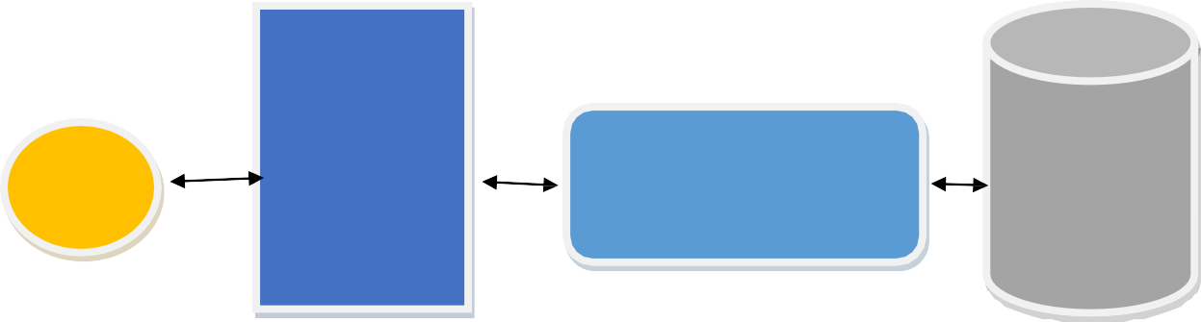
User
Web Server
Ticket Booking Management System
Database
Fig 4.1: System Architecture

User Requirements Specification

The software requirements specification document enlists the requirements that are required for the project development. To derive the requirements, the developer needs to have a clear and thorough understanding of the products to be developed. Also, the requirements must be described at length for making the client clear and concise about what is going to be developed. The user requirements are described in great detail in table 4.3.

Use Cases

A use case is a list of actions or event steps typically defining the interactions between a role and a system to achieve a goal. Use cases are important to understand how the system interacts with the user or other systems. The use cases of the system are listed in table 4.4.
Table 4.4: List of Use Cases
Use Case | Title
UC1 | Manage Passenger
UC2 | Manage Agency
UC3 | Add & Manage Admin
UC4 | Booked Tickets List
UC5 | Add & Manage Bus
UC6 | Add & Manage Launch
UC7 | Add & Manage Air
UC8 | Add & Manage Movie
UC9 | Add & Manage Event
UC10 | Booking Ticket List for Company
UC11 | Book Bus, Launch, Air, Movie, Event Ticket

Use Case Diagram
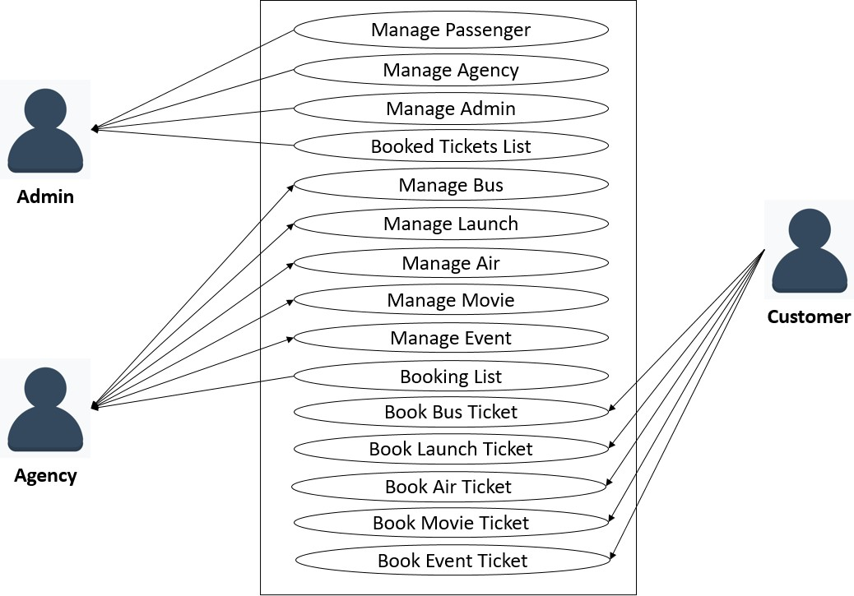
The use case diagram shows the interaction between the user and the system graphically. The use case diagram is shown in figure 4.2
Here, Admin can manage passenger, agency and admin. Admin can view booked ticket also. Agency can manage bus, launch, air, movie and event info. Agency check their booked list. Passenger can book bus, launch, air, movie and event ticket. Passenger can print their ticket and also can view upcoming events.

System Evolution

Over time, software systems, programs as well as applications, continue to develop. These changes will require new laws and theories to be created and justified. Software evolution is the term used in software engineering to refer to the process of developing software initially, then repeatedly updating it for various reasons. Ticket Booking Manage System is developed to be an adaptive system. It is implemented in such a way that it adjusts its performance concerning the specification of the hardware such as servers. With version 1.0, the system can process as much as 200 requests per second for a server with a processor speed of 3.3 GHz, consisted of 4 logical cores and a maximum memory of 4GB. Any change to the hardware would change the performance of the system in proportion to the change of processor speed, number of cores, and maximum memory.

Appendices
Appendices contain the texts that is explanatory, statistical, or bibliographic. The appendix for this document contains the hardware specification, database specification for the system.

Appendix A: Hardware Specification

The system is developed using the server “HPE ProLiant ML10 Gen9 Tower Server”. The specification of the server is given in Table 4.5:
Table 4.5: Server Specification
Processor | Intel® Xeon® E3-1225 v5
Number of Processors | 1
Processor Core Available | 4
Processor Cache | 8MB (1 x 8MB) Level 3 cache
Processor Speed | 3.3GHz
Chipset | Intel® C236 Chipset
Power Supply Type | 300W Multi-Output Power Supply
Memory | 4GB DDR4
Memory Slots | 4 DIMM slots
Memory Type | 1R x8 PC4-2133P-E-15
Memory Protection Features | Un-buffered ECC
Included Hard Drives | LFF SATA; 1TB
Maximum Internal Storage | 24TB
Optical Drive Type | SATA 9.5mm DVD RW
System Fan Features | Non-Pluggable Fan
Network Controller | Intel® Ethernet Connection I219-LM
Storage Controller | Integrated SATA RAID
Infrastructure Management | Intel® Active Management Technology (Intel® AMT 11.0)

Appendix B: Database Specification

The system uses the “MSSQL Enterprise Edition” as a database management system. The technical specification of the database management system is given in Table 4.6.
Table 4.6: Database Specification
Version | 5.7
Data Type | Static
Architecture | Relational Model
Operating System | Linux, Solaris, FreeBSD, Mac OS, Windows
Software License | GNU General Public License
Interface | GUI, CLI
Security | - SSL Support  - Built-in Data Encryption/Decryption  - View Support  - Triggers for auditing  - Query Logs for auditing
Access Control | ❖ Enterprise Directory Compatibility   Native Network Encryption   Run Privilege   Security Certification
Indexes | - R-/R+ Tree  - Hash  - Full-text  - Spatial
Partitioning | ▪ Range, Hash, List, Key  ▪ Composite  ▪ 8k partitions per table  ▪ Portable partitions between tables  ▪ Explicit querying by partition
 | 
Max Database Size | Unlimited
Max Table Size | 256 TB (MyISAM)  64 TB (Innodb)
Max Row Size | 64 KB
Max Column Per Row | 4096
Max Blob/Clob Size | 4 GB
Max CHAR Size | 64 KB
Max NUMBER Size | 64 Bit
Min Date Value | 1000
Max Date Value | 9999
Max Column Name Size | 64

4.10 Index

List of Figures
Figures are a graphical representation of information. The figures used in this document are listed in Table 5.7
Table 4.7: Figures are graphical representation
Figure Name | Name of Figure | Page No
Figure 5.1 | System Architecture | 20
Figure 4.1 | Use Case Diagram | 21

Alphabetical Index
A
Authentication, 21-23 C
Constraint, 21-22
Credentials, 22,25 D
Database, 22, 26, 32, 33 E
Encryption, 22, 25, 33 F
Failure Rate, 25 L
Login, 22, 24-27 O
On-line, 22-23
Operation, 23, 25 R
Requirement,
System Requirement, 21
Functional Requirement, 21-24
Non-functional Requirement, 21-22
User Requirement, 21-24
Response Time, 22, 25 S
Scenario, 22, 26-31
Server, 22, 26-30, 32
Software, 21, 23-26, 32-33
System Architecture, 22-23 System Model,
Conceptual Model, 23 T
Table VII: List of Figures U
Use Case, 21, 22, 26, 31

Chapter – 5 System Designing

Ticket Booking Management System is a computerized system developed to manage Ticket Bookings. The purpose of this chapter is to provide design details of the Ticket Booking Management System. This chapter includes the architectural design of the system and also the system model from external, structural, interactional, and behavioral perspectives.
The chapter is composed of five sections. Section 1 describes the architectural pattern of the system, class diagram of the system is shown in section 2, Section 3 shows the code map of the system, Section 4 shows the er-diagram of the system and the conclusion for this chapter is given in section 5.

Architectural Pattern
An architectural pattern is a general, reusable solution to a commonly occurring problem in software architecture within a given context. An architectural pattern defines the systems in terms of structural organization, components, connectors, and constraints on how they can be combined. It also addresses various issues in software engineering, such as performance, availability, reliability, maintainability, and security of a system. Bit Online Ticket Booking Web System (TBMS) System has a Three-tier architecture pattern. The architectural pattern of TBMS system is graphically shown in figure 5.1

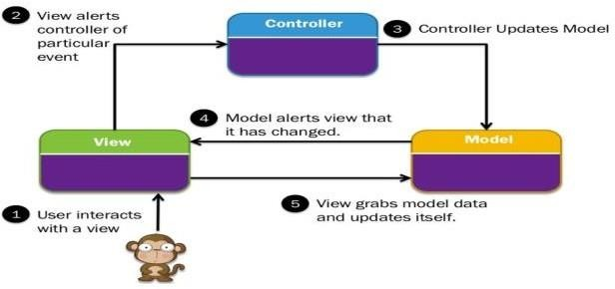
Figure 5.1: Architectural Pattern of Ticket Booking Management System

System Diagram

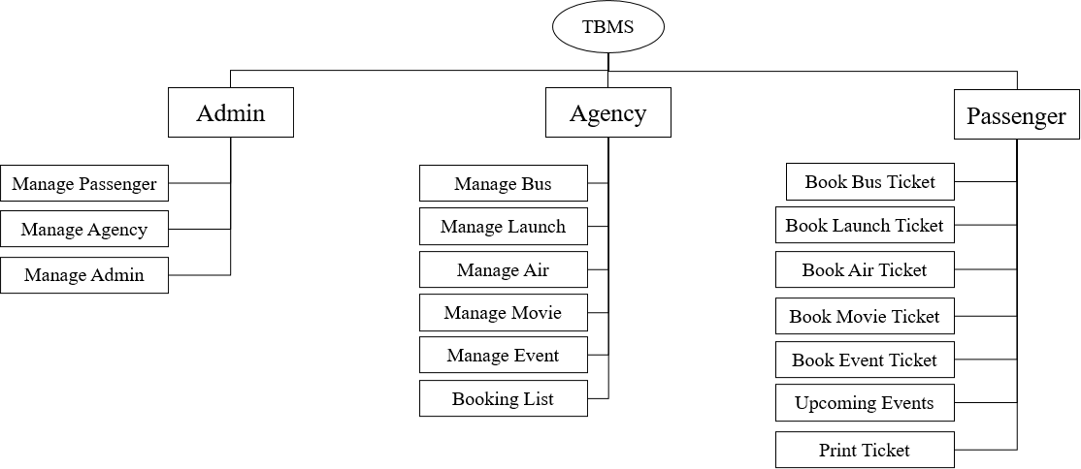
A system diagram could be a visual model of a system, its elements, and their interactions. With supporting documentation, it will capture all the essential data of a system's style. There square measure several variations of schematization vogue that everyone represents this rubric. the fashion conferred here is meant to be optimally in line with the remainder of this courseware.

Figure 5.2: System Diagram

ER Diagram

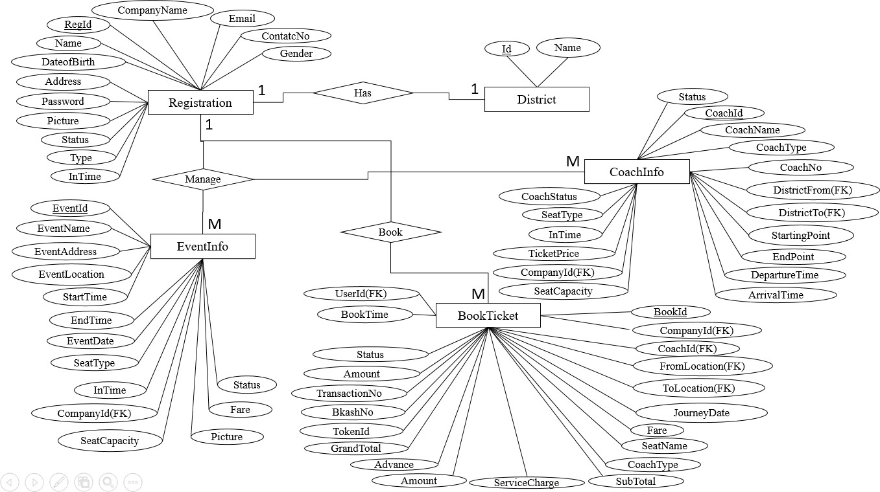
Entity-relationship diagram displays the relationships of entity set hold on in an exceedingly information. In alternative words, we will say that ER diagrams assist you to elucidate the logical structure of databases. initially look, associate degree ER diagram appearance terribly the same as the flow chart. However, ER Diagram includes several specialized symbols, and its meanings build this model distinctive.

Figure 5.3: ER Diagram

Conclusion

Implementation is the process of converting the design into an executable program. The design chapter for the Ticket Booking Management System will help the developers to develop the system efficiently and also enable the testers to verify and validate the system precisely, therefore creating a system that fulfills the user requirements and meeting the stakeholder’s expectation entirely.

Chapter – 6 Implementation

Ticket Booking Management System is a computerized system for management Ticket Bookings all works easily. The user interface (UI) is everything designed into an information device with which a person may interact. This can include display screens, keyboards, a mouse, and the appearance of a desktop. It is also the way through which a user interacts with an application or a website.

6.1 System Demonstration
The Ticket Booking management system is a web application with several functionalities. The functionalities of the system are shown using screenshots in the following figure 6.1 through 6.25.

Home
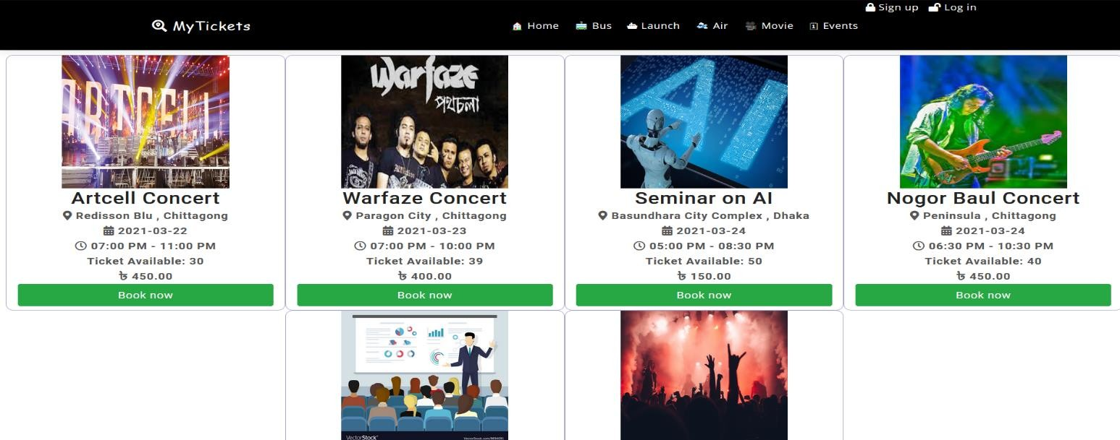
Fig 6.1: Home

Book Bus Ticket
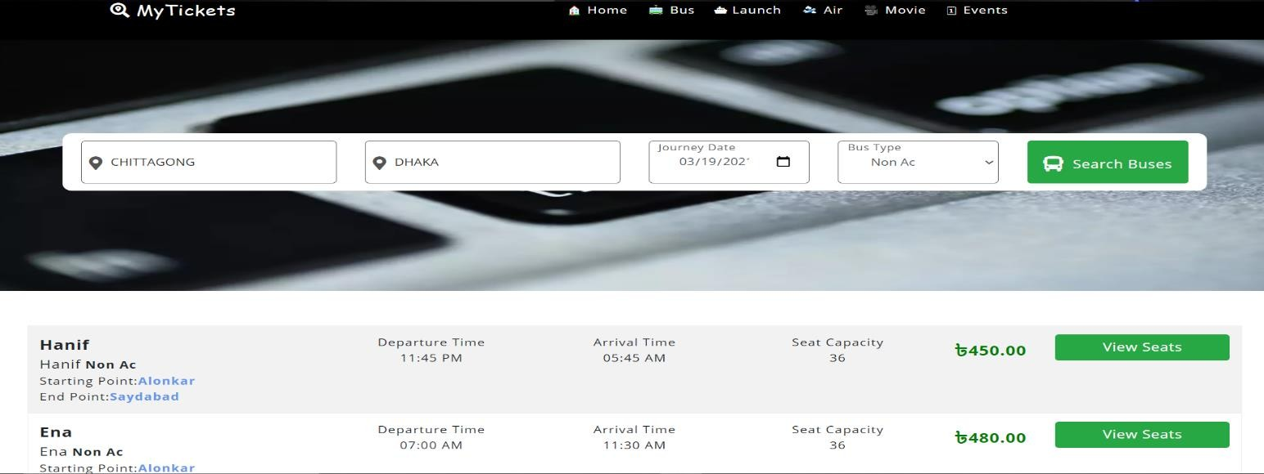
Fig 6.2: Book Bus Ticket

Book Bus Ticket
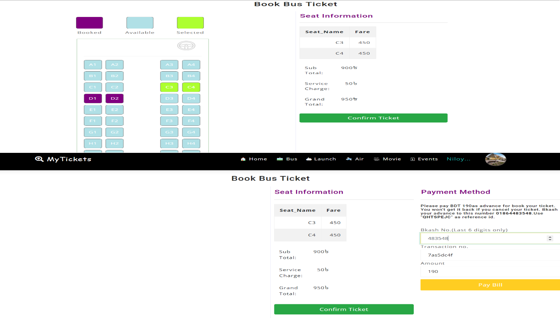
Fig 6.3: Book Bus Ticket

Book Launch Ticket
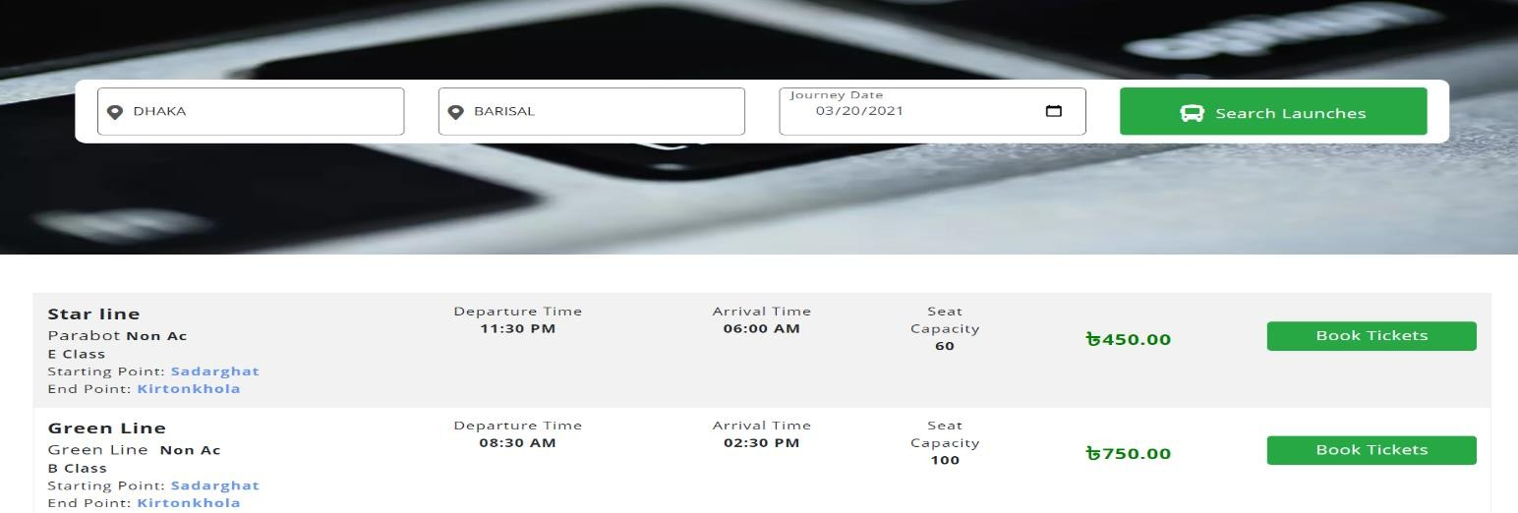
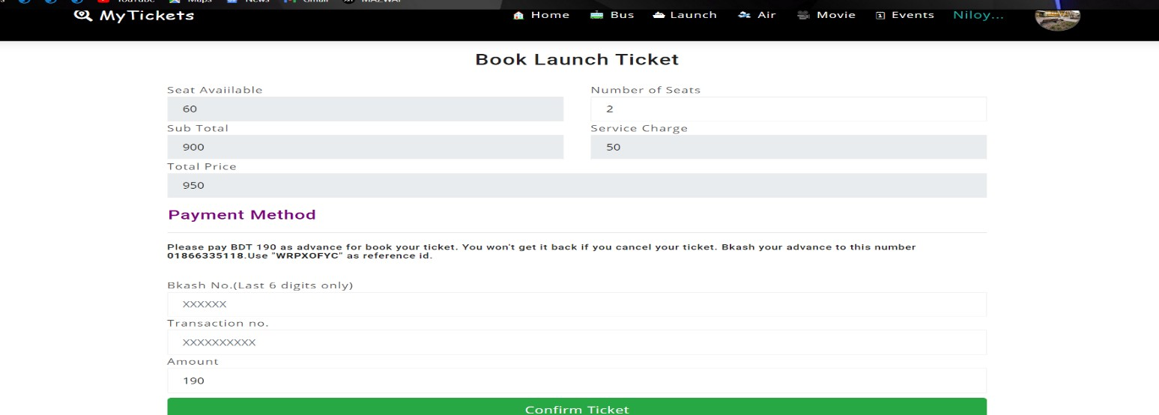

Fig 6.4: Book Launch Ticket

Book Air Ticket
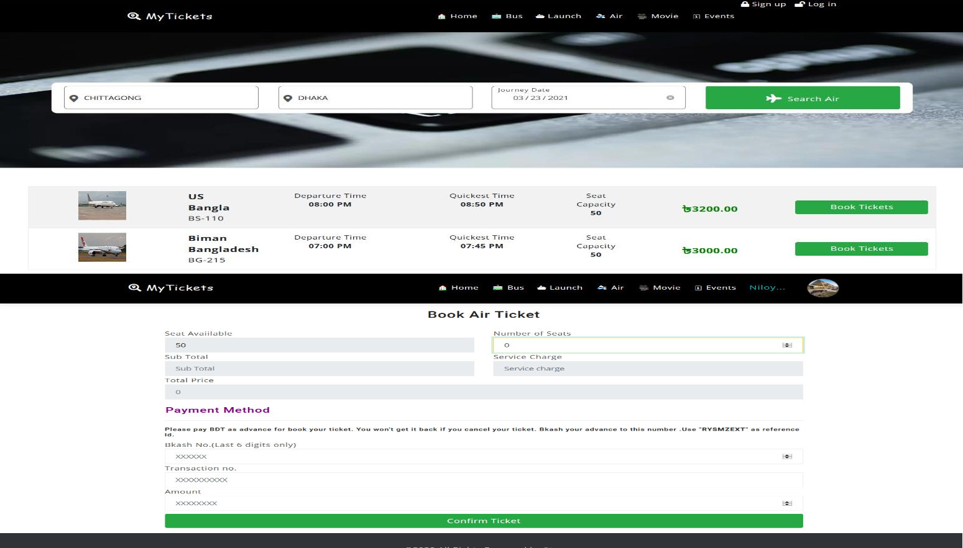
Fig 6.5 Book Air Ticket

Book Movie Ticket
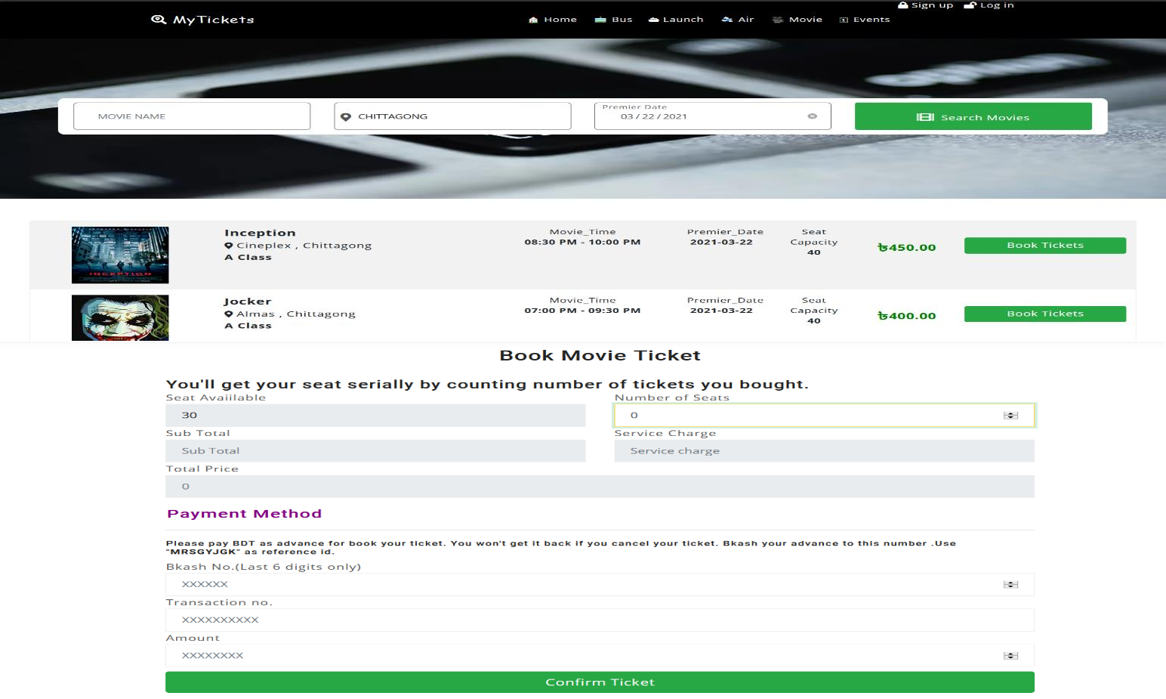
Fig 6.6 Book Movie Ticket

Book Event Ticket

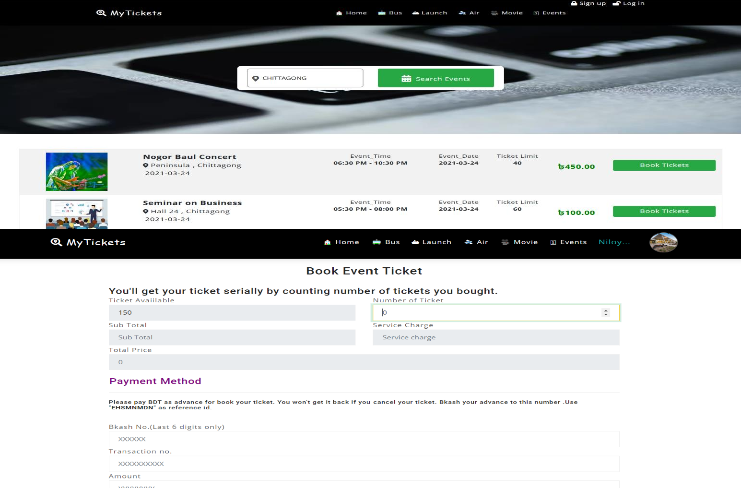

Sign up as Customer
Fig 6.7 Book Event Ticket

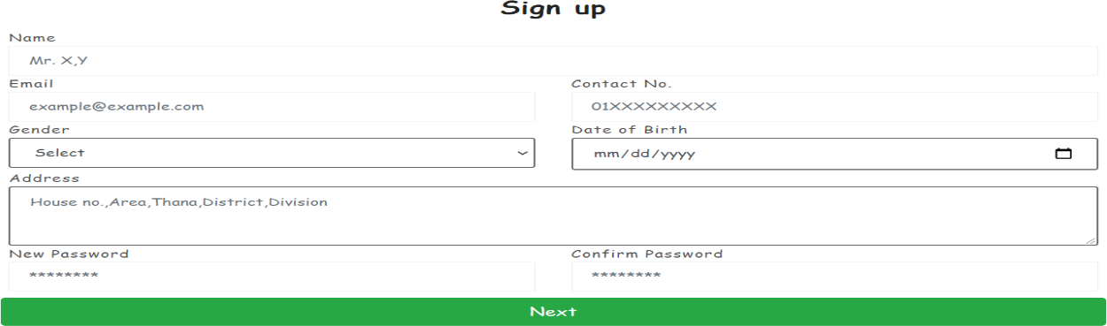

Fig 6.8 Sign up as Customer

Sign up as Agency
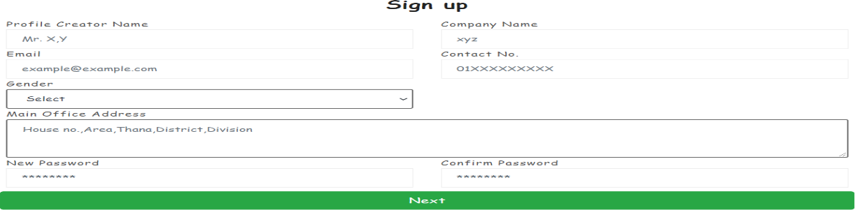

Fig 6.9 Sign up as Agency

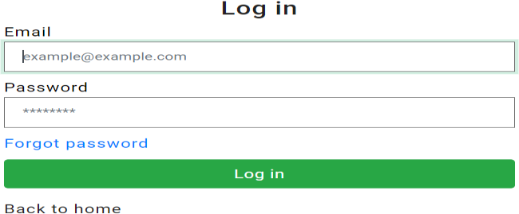
Login

Fig 6.10 Login

Add Bus
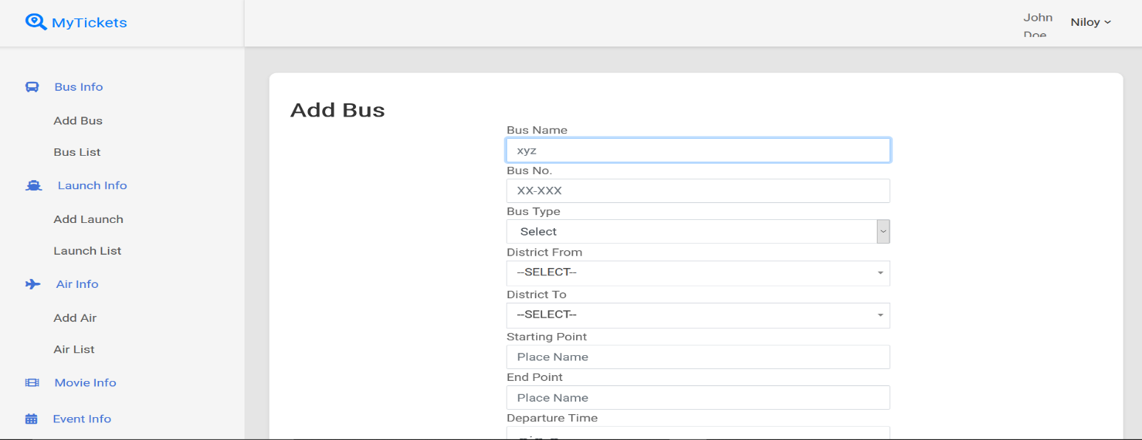

Fig 6.11: Add Bus

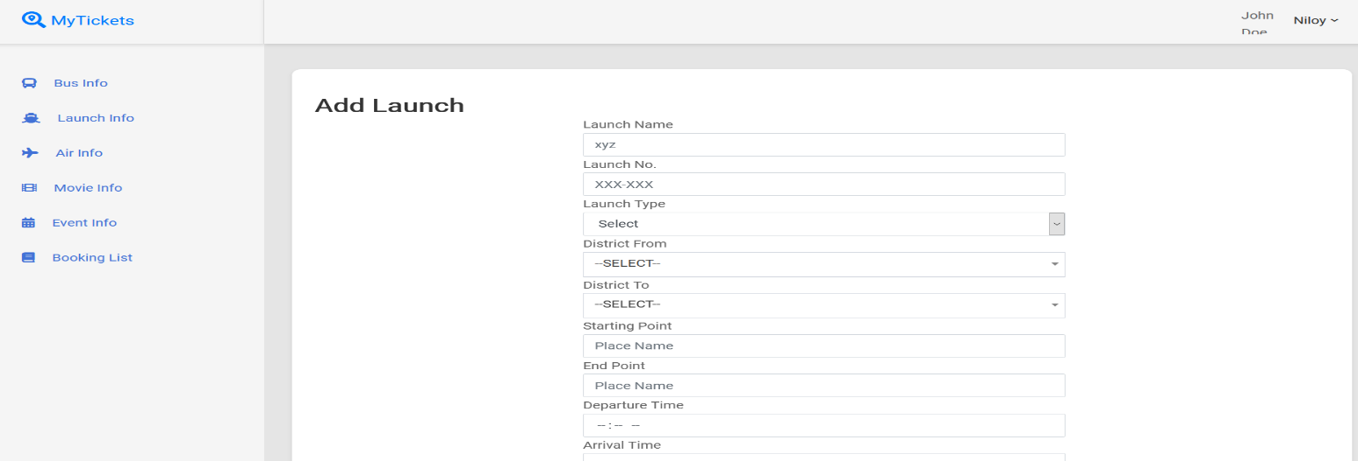
Add Launch
Fig 6.12: Add Launch

Add Air
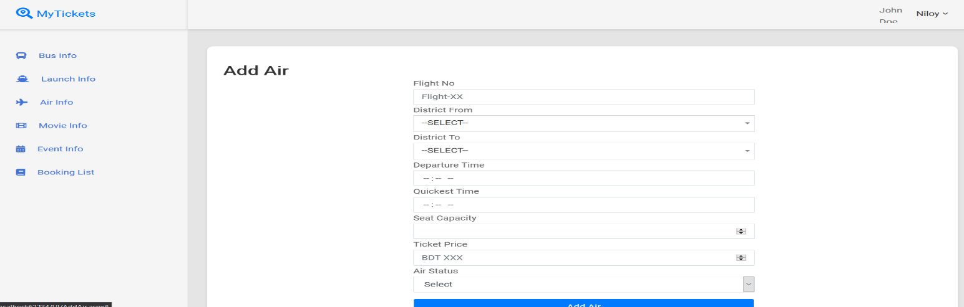
Fig 6.13: Add Air

Add Movie
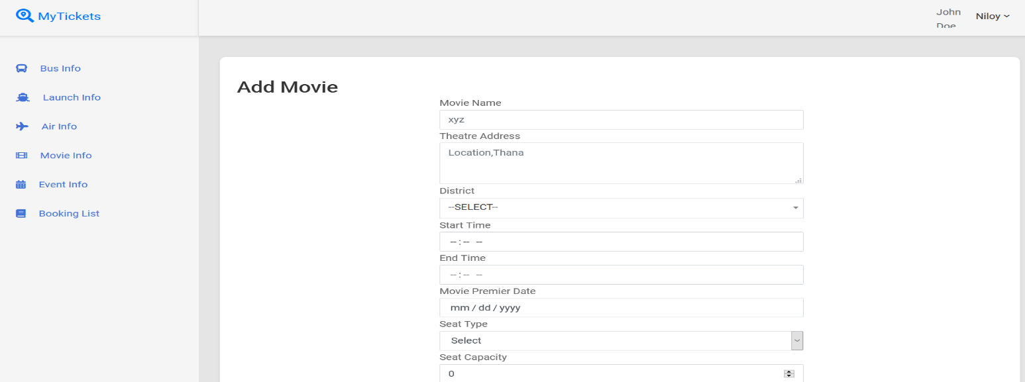
Fig 6.14: Add Movie

Add Event
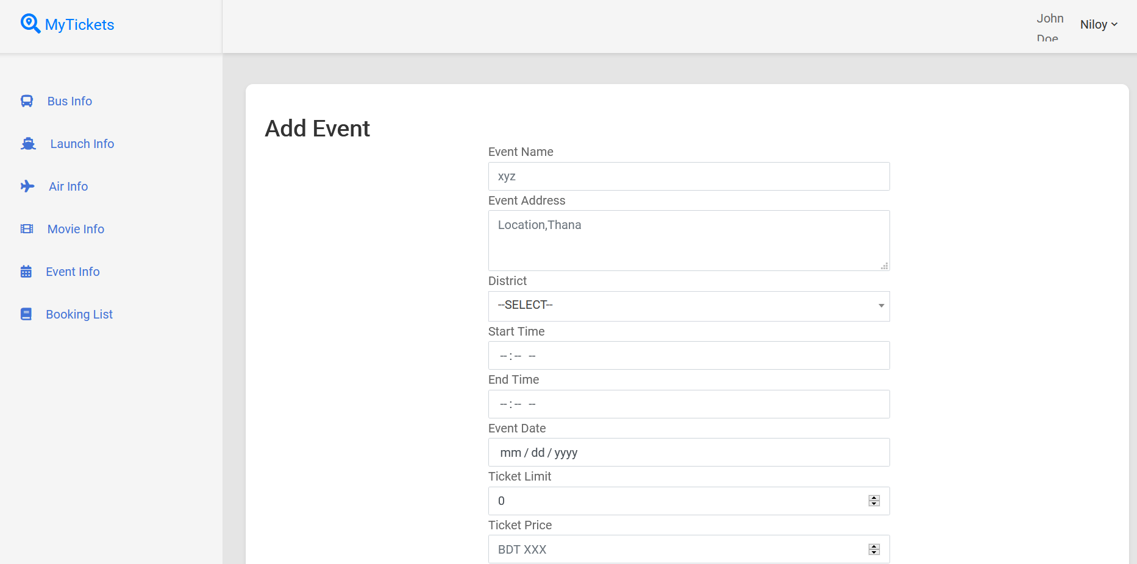
Fig 6.15: Add Event

Agency List
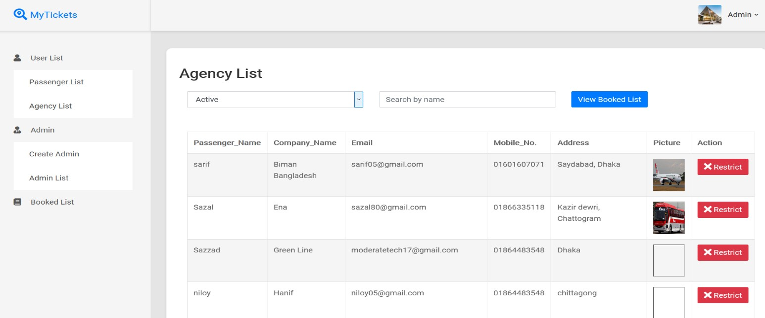
Fig 6.16: Agency List

Passenger List
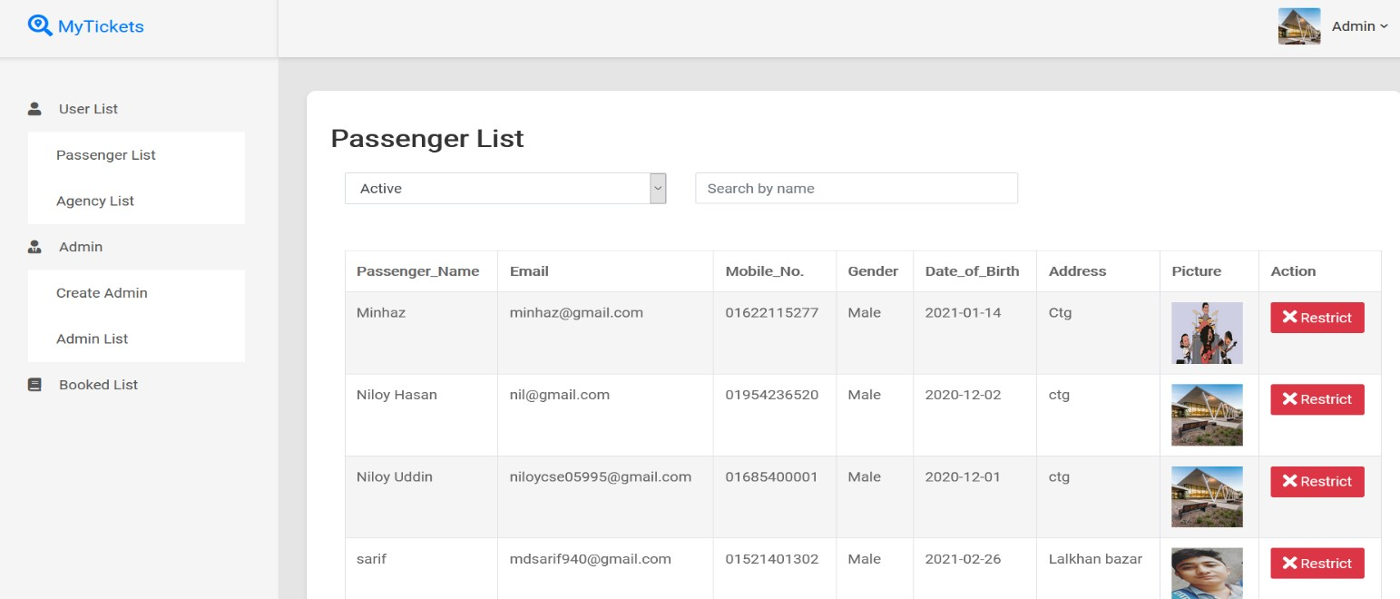
Fig 6.17: Passenger List

Booked List
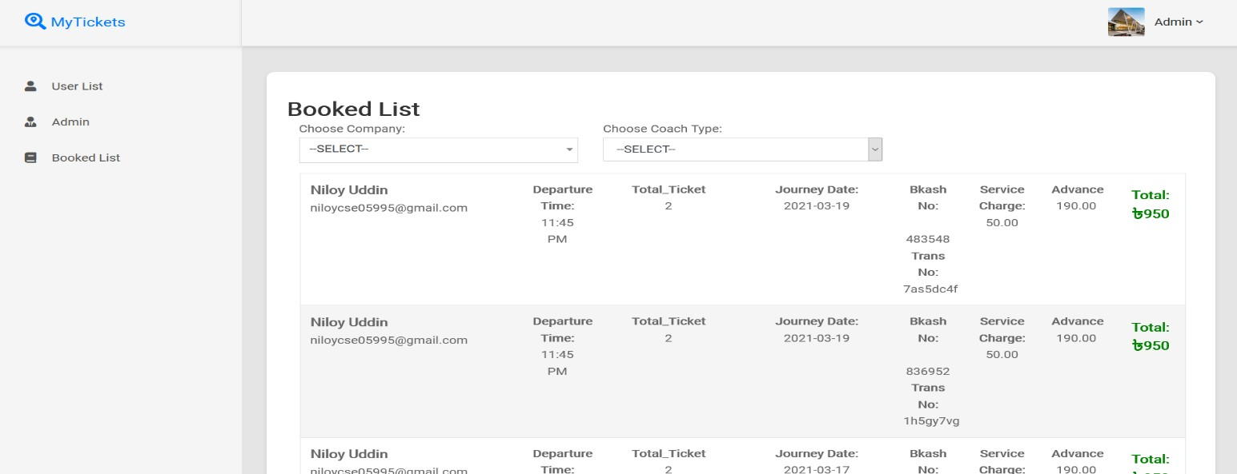
Fig 6.18: Booked List

Add Admin
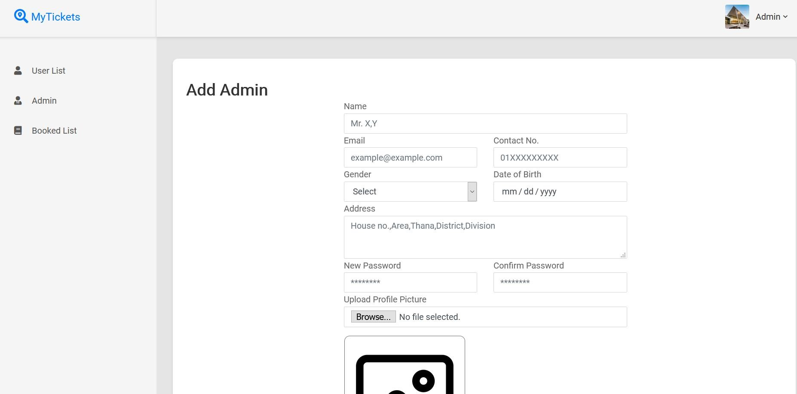

Fig 6.19: Add Admin

Admin List
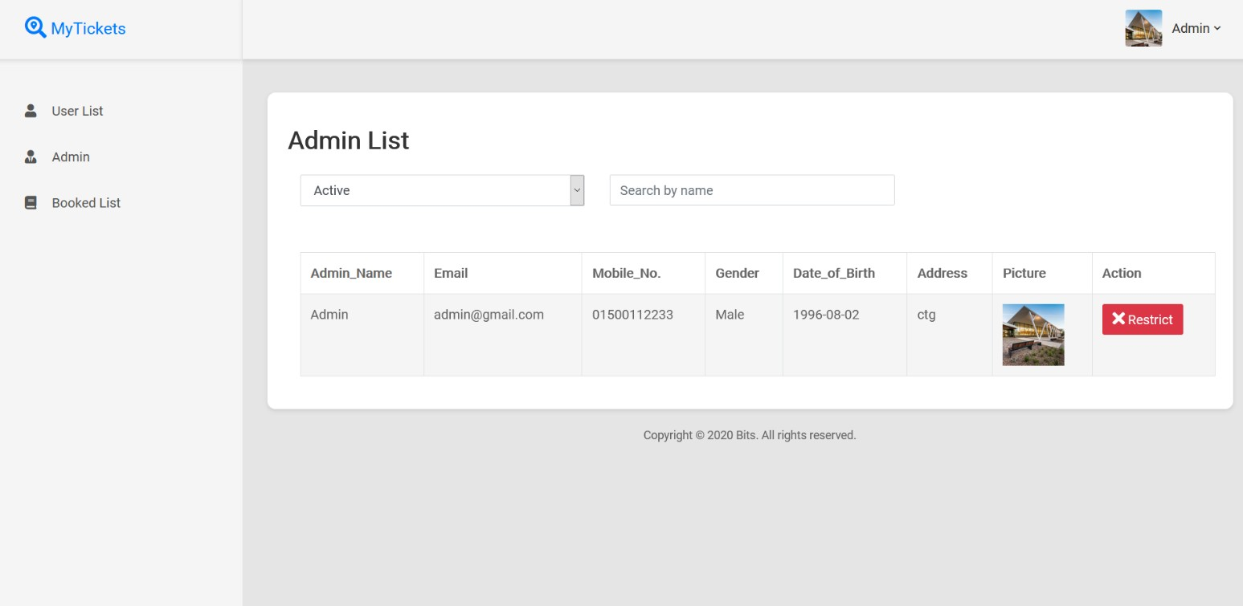
Fig 6.20: Admin List

Chapter – 7 Conclusion

System Limitation

There exists no system developed by man that is perfect and complete. TBMS System too has some limitations on its functions. The limitations of the Ticket Booking Management System are stated below:

    - There is no online payment system for registration.
    - There is no agency rating system.
    - Super Admin has to be added to the database manually.
    - Passenger can’t location agency pickup point in google map.
    - Agency can’t create sub account for their employees.
    - The system is available for only for web.

Future work

Technology is ever-changing. To cope up with the change and the satisfaction of a user, a system needs to be kept constantly updated. To overcome the limitations of the system as well as to satisfy the need of its user, the following changes are planned to make in future versions of this the system:
    - An online payment system will be added like bKash, PayPal.
    - Agency rating system will be added.
    - Passenger can location pickup point of agency.
    - Agency will be able to create sub account.
    - The system will be available for android so that all will be able to do their work separately.

Conclusion

The Ticket Booking management system is a computerized system focusing on managing Ticket Booking works. It is hoped that this system will work successfully. It will be helpful for passenger & agencies for book and manage ticket online. This system will be most useful for a Ticket Booking System.
Appendices

Model:
public class RegistrationModel
{
private static RegistrationModel _instance; public static RegistrationModel GetInstance()
{
if (_instance == null)
{
_instance = new RegistrationModel();
}
return _instance;
}

public string RegId { get; set; } public string Name { get; set; }
public string CompanyName { get; set; } public string Email { get; set; }
public string ContactNo { get; set; } public string Gender { get; set; } public string DateofBirth { get; set; } public string Address { get; set; } public string Password { get; set; } public string Picture { get; set; } public string Status { get; set; } public string Type { get; set; } public string InTime { get; set; }
}
public class EventModel
{
private static EventModel _instance; public static EventModel GetInstance()
{
if (_instance == null)
{
_instance = new EventModel();
}
return _instance;
}

public int EventId { get; set; }
public string EventName { get; set; } public string Picture { get; set; } public int EventLocation { get; set; }
public string EventAddress { get; set; } public double Fare { get; set; }
public string StartTime { get; set; } public string EndTime { get; set; } public string SeatType { get; set; } public int SeatCapacity { get; set; } public string EventDate { get; set; } public int CompanyId { get; set; } public string Status { get; set; } public string Type { get; set; }
public string InTime { get; set; } }
public class CoachModel
{
private static CoachModel _instance; public static CoachModel GetInstance()
{
if (_instance == null)
{
_instance = new CoachModel();
}
return _instance;
}

public int CoachId { get; set; }
public string CoachName { get; set; } public string CoachType { get; set; } public string CoachNo { get; set; } public int DistrictFrom { get; set; } public int DistrictTo { get; set; } public string StartingPoint { get; set; } public string EndPoint { get; set; }
public string DepartureTime { get; set; } public string ArrivalTime { get; set; } public double TicketPrice { get; set; } public string Status { get; set; }
public string CompanyId { get; set; } public string InTime { get; set; } public string SeatType { get; set; } public string CoachStatus { get; set; } public string SeatCapacity { get; set; }
}
public class BookTicketModal
{
private static BookTicketModal _instance; public static BookTicketModal GetInstance()
{
if (_instance == null)
{
_instance = new BookTicketModal();
}
return _instance;
}

public int BookId { get; set; } public int CompanyId { get; set; } public int CoachId { get; set; } public int FromLocation { get; set; } public int ToLocation { get; set; }
public string JourneyDate { get; set; } public double Fare { get; set; }
public string SeatName { get; set; } public string CoachType { get; set; } public double SubTotal { get; set; } public double ServiceCharge { get; set; } public double Advance { get; set; } public double GrandTotal { get; set; } public string TokenId { get; set; }
public string BkashNo { get; set; }
public string TransactionNo { get; set; }
public string Amount { get; set; } public string BookTime { get; set; } public string Status { get; set; } public string UserId { get; set; }
}

Gateway:
public class RegistrationGateway
{

private MasterClass;
private SqlConnection connection; private SqlCommand command;
private static RegistrationGateway _instance; public static RegistrationGateway GetInstance()
{
if (_instance == null)
{
_instance = new RegistrationGateway();
}
return _instance;
}
public RegistrationGateway()
{
masterClass = MasterClass.GetInstance();
connection = new SqlConnection(masterClass.Connection);
}

internal bool Save(RegistrationModel model)
{
bool result = false; SqlTransaction transaction = null; try
{
if (connection.State != ConnectionState.Open) connection.Open();
transaction = connection.BeginTransaction(); command = new SqlCommand("INSERT INTO
Registration(RegId,Name,CompanyName,Email,ContactNo,Gender,DateofBirth,Address,Password,Picture,Status, Type,InTime) VALUES(@RegId,@Name,@CompanyName,@Email,@ContactNo,@Gender,@DateofBirth,@Address,@Passw ord,@Picture,@Status,@Type,@InTime)", connection);
command.Parameters.AddWithValue("@RegId", model.RegId); command.Parameters.AddWithValue("@Name", model.Name); command.Parameters.AddWithValue("@CompanyName", model.CompanyName); command.Parameters.AddWithValue("@Email", model.Email); command.Parameters.AddWithValue("@ContactNo", model.ContactNo); command.Parameters.AddWithValue("@Gender", model.Gender); command.Parameters.AddWithValue("@DateofBirth", model.DateofBirth); command.Parameters.AddWithValue("@Address", model.Address); command.Parameters.AddWithValue("@Password", model.Password); command.Parameters.AddWithValue("@Picture", model.Picture); command.Parameters.AddWithValue("@Status", model.Status); command.Parameters.AddWithValue("@Type", model.Type); command.Parameters.AddWithValue("@InTime", model.InTime);

command.Transaction = transaction; command.ExecuteNonQuery();

transaction.Commit(); result = true;
if (connection.State != ConnectionState.Closed) connection.Close();
}
catch (Exception ex)
{
transaction.Rollback();
}
return result;
}
internal bool Update(RegistrationModel model)
{
bool result = false; SqlTransaction transaction = null; try
{
if (connection.State != ConnectionState.Open) connection.Open();
transaction = connection.BeginTransaction();
command = new SqlCommand("UPDATE Registration SET Picture=@Picture WHERE RegId=@RegId", connection);
command.Parameters.AddWithValue("@Picture", model.Picture); command.Parameters.AddWithValue("@RegId", model.RegId);

command.Transaction = transaction; command.ExecuteNonQuery(); transaction.Commit();
result = true;
if (connection.State != ConnectionState.Closed) connection.Close();
}
catch (Exception)
{
transaction.Rollback();
}
return result;
}
internal bool UpdateStatus(RegistrationModel model)
{
bool result = false; SqlTransaction transaction = null; try
{
if (connection.State != ConnectionState.Open) connection.Open();
transaction = connection.BeginTransaction();
command = new SqlCommand("UPDATE Registration SET Status=@Status WHERE RegId=@RegId", connection);
command.Parameters.AddWithValue("@Status", model.Status); command.Parameters.AddWithValue("@RegId", model.RegId);

command.Transaction = transaction; command.ExecuteNonQuery(); transaction.Commit();
result = true;
if (connection.State != ConnectionState.Closed)
connection.Close();
}
catch (Exception)
{
transaction.Rollback();
}
return result;
}
internal bool CreateAdmin(RegistrationModel model)
{
bool result = false; SqlTransaction transaction = null; try
{
if (connection.State != ConnectionState.Open) connection.Open();
transaction = connection.BeginTransaction(); command = new SqlCommand("INSERT INTO
Registration(RegId,Name,Email,ContactNo,Gender,DateofBirth,Address,Password,Picture,Status,Type,InTime) VALUES(@RegId,@Name,@Email,@ContactNo,@Gender,@DateofBirth,@Address,@Password,@Picture,@St atus,@Type,@InTime)", connection);
command.Parameters.AddWithValue("@RegId", model.RegId); command.Parameters.AddWithValue("@Name", model.Name); command.Parameters.AddWithValue("@Email", model.Email); command.Parameters.AddWithValue("@ContactNo", model.ContactNo); command.Parameters.AddWithValue("@Gender", model.Gender); command.Parameters.AddWithValue("@DateofBirth", model.DateofBirth); command.Parameters.AddWithValue("@Address", model.Address); command.Parameters.AddWithValue("@Password", model.Password); command.Parameters.AddWithValue("@Picture", model.Picture); command.Parameters.AddWithValue("@Status", model.Status); command.Parameters.AddWithValue("@Type", model.Type); command.Parameters.AddWithValue("@InTime", model.InTime);

command.Transaction = transaction; command.ExecuteNonQuery(); transaction.Commit();
result = true;
if (connection.State != ConnectionState.Closed) connection.Close();
}
catch (Exception)
{
transaction.Rollback();
}
return result;
}
}
public class EventGateway
{
private MasterClass;
private SqlConnection connection; private SqlCommand command; private static EventGateway _instance;
public static EventGateway GetInstance()
{
if (_instance == null)
{
_instance = new EventGateway();
}
return _instance;
}
public EventGateway()
{
masterClass = MasterClass.GetInstance();
connection = new SqlConnection(masterClass.Connection);
}
internal bool InsertEvent(EventModel model)
{
bool result = false; SqlTransaction transaction = null; try
{
if (connection.State != ConnectionState.Open) connection.Open();
transaction = connection.BeginTransaction(); command = new SqlCommand("INSERT INTO
EventInfo(EventName,EventAddress,EventLocation,StartTime,EndTime,EventDate,SeatType,SeatCapacity,Fare, Picture,CompanyId,Status,InTime,Type) VALUES(@EventName,@EventAddress,@EventLocation,@StartTime,@EndTime,@EventDate,@SeatType,@S eatCapacity,@Fare,@Picture,@CompanyId,@Status,@InTime,@Type)", connection);
command.Parameters.AddWithValue("@EventName", model.EventName); command.Parameters.AddWithValue("@EventAddress", model.EventAddress); command.Parameters.AddWithValue("@EventLocation", model.EventLocation); command.Parameters.AddWithValue("@StartTime", model.StartTime); command.Parameters.AddWithValue("@EndTime", model.EndTime); command.Parameters.AddWithValue("@EventDate", model.EventDate); command.Parameters.AddWithValue("@SeatType", model.SeatType); command.Parameters.AddWithValue("@SeatCapacity", model.SeatCapacity); command.Parameters.AddWithValue("@Fare", model.Fare); command.Parameters.AddWithValue("@Picture", model.Picture); command.Parameters.AddWithValue("@CompanyId", model.CompanyId); command.Parameters.AddWithValue("@Status", model.Status); command.Parameters.AddWithValue("@InTime", model.InTime); command.Parameters.AddWithValue("@Type", model.Type);

command.Transaction = transaction; command.ExecuteNonQuery(); transaction.Commit();
result = true;
if (connection.State != ConnectionState.Closed) connection.Close();
}
catch (Exception ex)
{
transaction.Rollback();
}
return result;
}

internal bool UpdateEventStatus(EventModel model)
{
bool result = false; SqlTransaction transaction = null; try
{
if (connection.State != ConnectionState.Open)
connection.Open();
transaction = connection.BeginTransaction();
command = new SqlCommand("UPDATE EventInfo SET Status=@Status WHERE EventId=@EventId", connection);
command.Parameters.AddWithValue("@Status", model.Status); command.Parameters.AddWithValue("@EventId", model.EventId);

command.Transaction = transaction; command.ExecuteNonQuery(); transaction.Commit();
result = true;
if (connection.State != ConnectionState.Closed) connection.Close();
}
catch (Exception)
{
transaction.Rollback();
}
return result;
}
internal bool UpdateEvent(EventModel model)
{
bool result = false; SqlTransaction transaction = null; try
{
if (connection.State != ConnectionState.Open) connection.Open();
transaction = connection.BeginTransaction();
command = new SqlCommand("UPDATE EventInfo SET EventName=@EventName, EventAddress=@EventAddress,EventLocation=@EventLocation,StartTime=@StartTime,EndTime=@EndTime,E ventDate=@EventDate,SeatType=@SeatType,SeatCapacity=@SeatCapacity,Fare=@Fare,Picture=@Picture,Statu s=@Status WHERE EventId=@EventId", connection);
command.Parameters.AddWithValue("@EventAddress", model.EventAddress); command.Parameters.AddWithValue("@EventLocation", model.EventLocation); command.Parameters.AddWithValue("@StartTime", model.StartTime); command.Parameters.AddWithValue("@EndTime", model.EndTime); command.Parameters.AddWithValue("@EventDate", model.EventDate); command.Parameters.AddWithValue("@SeatType", model.SeatType); command.Parameters.AddWithValue("@SeatCapacity", model.SeatCapacity); command.Parameters.AddWithValue("@Fare", model.Fare); command.Parameters.AddWithValue("@Picture", model.Picture); command.Parameters.AddWithValue("@Status", model.Status); command.Parameters.AddWithValue("@EventName", model.EventName); command.Parameters.AddWithValue("@EventId", model.EventId);

command.Transaction = transaction; command.ExecuteNonQuery(); transaction.Commit();
result = true;
if (connection.State != ConnectionState.Closed) connection.Close();
}
catch (Exception ex)
{
transaction.Rollback();
}
return result;
}
}
public class CoachGateway
{
private MasterClass;
private SqlConnection connection; private SqlCommand command; private static CoachGateway _instance;
public static CoachGateway GetInstance()
{
if (_instance == null)
{
_instance = new CoachGateway();
}
return _instance;
}
public CoachGateway()
{
masterClass = MasterClass.GetInstance();
connection = new SqlConnection(masterClass.Connection);
}
internal bool AddBus(CoachModel model)
{
bool result = false; SqlTransaction transaction = null; try
{
if (connection.State != ConnectionState.Open) connection.Open();
transaction = connection.BeginTransaction(); command = new SqlCommand("INSERT INTO
CoachInfo(CoachName,CoachType,CoachNo,DistrictFrom,DistrictTo,StartingPoint,EndPoint,DepartureTime,Arri valTime,TicketPrice,Status,CompanyId,InTime,SeatType,CoachStatus,SeatCapacity) VALUES(@CoachName,@CoachType,@CoachNo,@DistrictFrom,@DistrictTo,@StartingPoint,@EndPoint,@D epartureTime,@ArrivalTime,@TicketPrice,@Status,@CompanyId,@InTime,@SeatType,@CoachStatus,@SeatC apacity)", connection);
command.Parameters.AddWithValue("@CoachName", model.CoachName); command.Parameters.AddWithValue("@CoachType", model.CoachType); command.Parameters.AddWithValue("@CoachNo", model.CoachNo); command.Parameters.AddWithValue("@DistrictFrom", model.DistrictFrom); command.Parameters.AddWithValue("@DistrictTo", model.DistrictTo); command.Parameters.AddWithValue("@StartingPoint", model.StartingPoint); command.Parameters.AddWithValue("@EndPoint", model.EndPoint); command.Parameters.AddWithValue("@DepartureTime", model.DepartureTime); command.Parameters.AddWithValue("@ArrivalTime", model.ArrivalTime); command.Parameters.AddWithValue("@TicketPrice", model.TicketPrice); command.Parameters.AddWithValue("@Status", model.Status); command.Parameters.AddWithValue("@CompanyId", model.CompanyId); command.Parameters.AddWithValue("@InTime", model.InTime); command.Parameters.AddWithValue("@SeatType", model.SeatType); command.Parameters.AddWithValue("@CoachStatus", model.CoachStatus); command.Parameters.AddWithValue("@SeatCapacity", model.SeatCapacity);

command.Transaction = transaction; command.ExecuteNonQuery(); transaction.Commit();
result = true;
if (connection.State != ConnectionState.Closed)
connection.Close();
}
catch (Exception ex)
{
string x=ex.Message; transaction.Rollback();
}
return result;
}
internal bool Delete(CoachModel model)
{
bool result = false; SqlTransaction transaction = null; try
{
if (connection.State != ConnectionState.Open) connection.Open();
transaction = connection.BeginTransaction();
command = new SqlCommand("DELETE FROM CoachInfo WHERE CoachId=@CoachId", connection);
command.Parameters.AddWithValue("@CoachId", model.CoachId);

command.Transaction = transaction; command.ExecuteNonQuery(); transaction.Commit();
result = true;
if (connection.State != ConnectionState.Closed) connection.Close();
}
catch (Exception)
{
transaction.Rollback();
}
return result;
}
internal bool UpdateStatus(CoachModel coachModel)
{
bool result = false; SqlTransaction transaction = null; try
{
if (connection.State != ConnectionState.Open) connection.Open();
transaction = connection.BeginTransaction();
command = new SqlCommand("UPDATE CoachInfo SET Status=@Status WHERE CoachId=@CoachId", connection);
command.Parameters.AddWithValue("@Status", coachModel.Status); command.Parameters.AddWithValue("@CoachId", coachModel.CoachId);

command.Transaction = transaction; command.ExecuteNonQuery(); transaction.Commit();
result = true;
if (connection.State != ConnectionState.Closed) connection.Close();
}
catch (Exception)
{
transaction.Rollback();
}
return result;
}
internal bool UpdateAir(CoachModel model)
{
bool result = false; SqlTransaction transaction = null; try
{
if (connection.State != ConnectionState.Open) connection.Open();
transaction = connection.BeginTransaction();
command = new SqlCommand("UPDATE CoachInfo SET CoachName=@CoachName,DistrictFrom=@DistrictFrom,DistrictTo=@DistrictTo,DepartureTime=@DepartureT ime,ArrivalTime=@ArrivalTime,TicketPrice=@TicketPrice,SeatCapacity=@SeatCapacity WHERE CoachId=@CoachId", connection);
command.Parameters.AddWithValue("@CoachName", model.CoachName); command.Parameters.AddWithValue("@DistrictFrom", model.DistrictFrom); command.Parameters.AddWithValue("@DistrictTo", model.DistrictTo); command.Parameters.AddWithValue("@DepartureTime", model.DepartureTime); command.Parameters.AddWithValue("@ArrivalTime", model.ArrivalTime); command.Parameters.AddWithValue("@TicketPrice", model.TicketPrice); command.Parameters.AddWithValue("@SeatCapacity", model.SeatCapacity); command.Parameters.AddWithValue("@CoachId", model.CoachId);

command.Transaction = transaction; command.ExecuteNonQuery(); transaction.Commit();
result = true;
if (connection.State != ConnectionState.Closed) connection.Close();
}
catch (Exception)
{
transaction.Rollback();
}
return result;
}
}
public class BookTicketGateway
{
private MasterClass;
private SqlConnection connection; private SqlCommand command;
private static BookTicketGateway _instance; public static BookTicketGateway GetInstance()
{
if (_instance == null)
{
_instance = new BookTicketGateway();
}
return _instance;
}
public BookTicketGateway()
{
masterClass = MasterClass.GetInstance();
connection = new SqlConnection(masterClass.Connection);
}
internal bool BookTicket(BookTicketModal modal)
{
bool result = false; SqlTransaction transaction = null; try
{
if (connection.State != ConnectionState.Open) connection.Open();
transaction = connection.BeginTransaction(); command = new SqlCommand("INSERT INTO
BookTicket(CompanyId,CoachId,FromLocation,ToLocation,JourneyDate,Fare,SeatName,CoachType,SubTotal,Se rviceCharge,Advance,GrandTotal,TokenId,BkashNo,TransactionNo,Amount,BookTime,Status,UserId) VALUES(@CompanyId,@CoachId,@FromLocation,@ToLocation,@JourneyDate,@Fare,@SeatName,@CoachT ype,@SubTotal,@ServiceCharge,@Advance,@GrandTotal,@TokenId,@BkashNo,@TransactionNo,@Amount,@ BookTime,@Status,@UserId)", connection);
command.Parameters.AddWithValue("@CompanyId", modal.CompanyId); command.Parameters.AddWithValue("@CoachId", modal.CoachId); command.Parameters.AddWithValue("@FromLocation", modal.FromLocation); command.Parameters.AddWithValue("@ToLocation", modal.ToLocation); command.Parameters.AddWithValue("@JourneyDate", modal.JourneyDate); command.Parameters.AddWithValue("@Fare", modal.Fare); command.Parameters.AddWithValue("@SeatName", modal.SeatName); command.Parameters.AddWithValue("@CoachType", modal.CoachType); command.Parameters.AddWithValue("@SubTotal", modal.SubTotal); command.Parameters.AddWithValue("@ServiceCharge", modal.ServiceCharge); command.Parameters.AddWithValue("@Advance", modal.Advance); command.Parameters.AddWithValue("@GrandTotal", modal.GrandTotal); command.Parameters.AddWithValue("@TokenId", modal.TokenId); command.Parameters.AddWithValue("@BkashNo", modal.BkashNo); command.Parameters.AddWithValue("@TransactionNo", modal.TransactionNo); command.Parameters.AddWithValue("@Amount", modal.Amount); command.Parameters.AddWithValue("@BookTime", modal.BookTime); command.Parameters.AddWithValue("@Status", modal.Status); command.Parameters.AddWithValue("@UserId", modal.UserId);

command.Transaction = transaction; command.ExecuteNonQuery(); transaction.Commit();
result = true;
if (connection.State != ConnectionState.Closed) connection.Close();
}
catch (Exception ex)
{
transaction.Rollback();
}
return result;
}
internal bool UpdateStatus(BookTicketModal modal)
{
bool result = false; SqlTransaction transaction = null; try
{
if (connection.State != ConnectionState.Open) connection.Open();
transaction = connection.BeginTransaction();
command = new SqlCommand("UPDATE BookTicket SET Status=@Status WHERE TokenId=@TokenId", connection);
command.Parameters.AddWithValue("@Status", modal.Status); command.Parameters.AddWithValue("@TokenId", modal.TokenId);

command.Transaction = transaction; command.ExecuteNonQuery(); transaction.Commit();
result = true;
if (connection.State != ConnectionState.Closed) connection.Close();
}
catch (Exception)
{
transaction.Rollback();
}
return result;
}
internal bool UpdateNAC(BookTicketModal ob)
{
bool result = false; SqlTransaction transaction = null; try
{
if (connection.State != ConnectionState.Open) connection.Open();
transaction = connection.BeginTransaction();
command = new SqlCommand("UPDATE BookTicket SET BkashNo=@BkashNo,TransactionNo=@TransactionNo,Amount=@Amount WHERE TokenId=@TokenId", connection);
command.Parameters.AddWithValue("@BkashNo", ob.BkashNo); command.Parameters.AddWithValue("@TransactionNo", ob.TransactionNo); command.Parameters.AddWithValue("@Amount", ob.Amount); command.Parameters.AddWithValue("@TokenId", ob.TokenId);

command.Transaction = transaction; command.ExecuteNonQuery(); transaction.Commit();
result = true;
if (connection.State != ConnectionState.Closed) connection.Close();
}
catch (Exception ex)
{
transaction.Rollback();
}
return result;
}
}

